DIGITAL NOTES

**THERMODYNAMICS**

**B.Tech II Year I Semester**

**DEPARTMENT OF MECHANICAL ENGINEERING**



**DEPATMENT OF MECHANICAL ENGINEERING,MRCET**

## II Year B. Tech ME-I Sem

**Objectives**:

# (R17A0303) THERMODYNAMICS

* To understand the concepts of energy transformation, conversion of heat into work.
* To understand the fundamentals of Differences between work producing and work consuming cycles.
* To apply the concepts of thermodynamics to basic energy systems.

## UNIT-I

Basic Concepts : System - Types of Systems - Control Volume - Macroscopic and Microscopic viewpoints - Thermodynamic Equilibrium- State, Property, Process, Cycle – Reversibility – Quasi static Process, Irreversible Process, Causes of Irreversibility – Work and Heat, Point and Path functions. Zeroth Law of Thermodynamics – Principles of Thermometry –Constant Volume gas Thermometer – Scales of Temperature – PMM I - Joule’s Experiment – First law of Thermodynamics – Corollaries – First law applied to a Process – applied to a flow system

– Steady Flow Energy Equation.

## UNIT-II

Limitations of the First Law - Thermal Reservoir, Heat Engine, Heat pump, Parameters of performance, Second Law of Thermodynamics, Kelvin-Planck and Clausius Statements and their Equivalence / Corollaries, PMM of Second kind, Carnot’s principle, Carnot cycle and its specialties, Clausius Inequality, Entropy, Principle of Entropy Increase – Energy Equation, Availability and Irreversibility – Thermodynamic Potentials, Gibbs and Helmholtz Functions, Maxwell Relations – Elementary Treatment of the Third Law of Thermodynamics.

## UNIT-III

**Pure Substances:** p-V-T- surfaces, T-S and h-s diagrams, Mollier Charts, Phase Transformations – Triple point at critical state properties during change of phase, Dryness Fraction – Mollier charts – Various Thermodynamic processes and energy Transfer – Steam Calorimetry. Perfect Gas Laws – Equation of State, specific and Universal Gas constants – Various Non-flow processes, properties, end states, Heat and Work Transfer, changes in Internal Energy – Throttling and Free Expansion Processes – Flow processes – Deviations from perfect Gas Model – Vander Waals Equation of State.

## UNIT-IV

**Mixtures of perfect Gases :** Mole Fraction, Mass friction Gravimetric and volumetric Analysis – Dalton’s Law of partial pressure, Avogadro’s Laws of additive volumes – Mole fraction , Volume fraction and partial pressure, Equivalent Gas constant, Enthalpy, sp. Heats and Entropy of Mixture of perfect Gases, Vapour, and Atmospheric air - Psychrometric Properties – Dry bulb Temperature, Wet Bulb Temperature, Dew point Temperature, Thermodynamic Wet Bulb Temperature, Specific Humidity, Relative Humidity, saturated Air, Vapour pressure, Degree of saturation – Adiabatic Saturation – Psychrometric chart.

## UNI-V

**Power Cycles :** Otto cycle, Diesel cycle, Dual Combustion cycles description and representation on P–V and T-S diagram, Thermal Efficiency, Mean Effective Pressures on Air standard basis – Comparison of Cycles. Basic Rankine cycle – Performance Evaluation.

## TEXT BOOKS:

1. Engineering Thermodynamics, Special Edition. MRCET, McGrahill Publishers.
2. Engineering Thermodynamics / PK Nag /TMH, III Edition
3. Thermodynamics – J.P.Holman / McGrawHill

## REFERENCE BOOKS:

1. Engineering Thermodynamics – Jones & Dugan
2. Thermodynamics – An Engineering Approach – Yunus Cengel & Boles /TMH
3. An introduction to Thermodynamics / YVC Rao / New Age
4. Engineering Thermodynamics – K. Ramakrishna / Anuradha Publisher

## OUTCOMES:

* Learner should be able to demonstrate understanding of basic concepts of thermodynamics.
* To differentiate between quality and quantity of energy, heat and work, enthalpy and entropy, etc.
  + To Analyze basic power cycles, Apply the laws of thermodynamics to various real life systems

# COURSE COVERAGE

|  |  |  |  |
| --- | --- | --- | --- |
| **S.NO** | **NAME OF THE UNIT** | **NAME OF THE TEXTBOOK** | **CHAPTERS COVERED** |
| 1 | Basic Concepts | Thermodynamics by P.K. Nag  Engineering Thermodynamics  – K. Ramakrishna | 1,2,3  1,2 |
| 2 | Limitations of the First Law | Thermodynamics by P.K. Nag | 2,3,4 |
| 3 | Pure Substances | Thermodynamics by P.K. Nag  Engineering Thermodynamics  – K. Ramakrishna | 3,4,5,6  4,5,6 |
| 4 | Mixtures of perfect Gases | Thermodynamics by P.K. Nag | 3,4,5,6,7,8 |
| 5 | Power Cycles | Thermodynamics by P.K. Nag | 7,8,9,10 |

**CONTENTS**

|  |  |  |
| --- | --- | --- |
| **S.No** | **Name of the Unit** | **Page No** |
| 1 | Basic Concepts | 2 |
| 2 | Limitations of the First Law | 18 |
| 3 | Pure Substances | 56 |
| 4 | Mixtures of perfect Gases | 73 |
| 5 | Power Cycles | 95 |
| 6 | Question Bank | 116 |
| 7 | Case Study | 123 |

# UNIT I

## System:

A thermodynamic system is defined as a quantity of matter or a region in space which is selected for the study.

## Suroundings:

The mass or region outside the system is called surroundings.

## Boundary:

The real or imaginary surfaces which separates the system and surroundings is called boundary. The real or imaginary surfaces which separates the system and surroundings is called boundary.

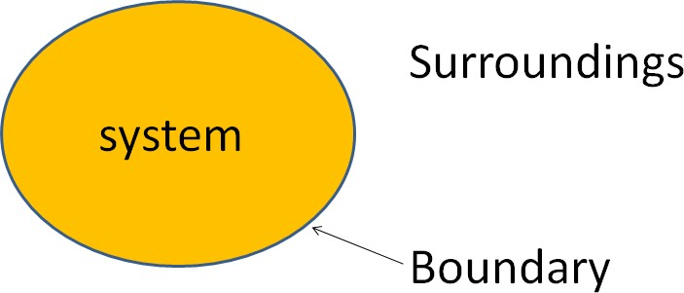

Types of thermodynamic system

On the basis of mass and energy transfer the thermodynamic system is divided into three types.

* 1. Closed system
  2. Open system
  3. Isolated system

**Closed system**: A system in which the transfer of energy but not mass can takes place across the boundary is called closed system. The mass inside the closed system remains constant.

For example: Boiling of water in a closed vessel. Since the water is boiled in closed vessel so the mass of water cannot escapes out of the boundary of the system but heat energy continuously entering and leaving the boundary of the vessel. It is an example of closed system.

**Open system:** A system in which the transfer of both mass and energy takes place is called an open system. This system is also known as control volume.

For example: Boiling of water in an open vessel is an example of open system because the water and heat energy both enters and leaves the boundary of the vessel.

**Isolated system:** A system in which the transfer of mass and energy cannot takes place is called an isolated system.

For example: Tea present in a thermos flask. In this the heat and the mass of the tea cannot cross the boundary of the thermos flask. Hence the thermos flak is an isolated system.

## Control Volume:

* Its a system of fixed volume.
* This type of system is usually referred to as "open system” or a "control volume"
* Mass transfer can take place across a control volume.
* Energy transfer may also occur into or out of the system.
* Control Surface- Its the boundary of a control volume across which the transfer of both mass and energy takes place.
* The mass of a control volume (open system) may or may not be fixed.
* When the net influx of mass across the control surface equals zero then the mass of the system is fixed and vice-versa.
* The identity of mass in a control volume always changes unlike the case for a control mass system (closed system).
* Most of the engineering devices, in general, represent an open system or control
* volume.

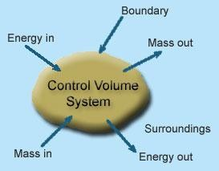

Example:

Heat exchanger - Fluid enters and leaves the system continuously with the transfer of heat across the system boundary.

Pump - A continuous flow of fluid takes place through the system with a transfer of mechanical energy from the surroundings to the system

## Microscopic Approach:

* The approach considers that the system is made up of a very large number of discrete particles known as molecules. These molecules have different velocities are energies. The values of these energies are constantly changing with time. This approach to thermodynamics, which is concerned directly with the structure of the matter, is known as statistical thermodynamics.
* The behavior of the system is found by using statistical methods, as the number of molecules is very large. So advanced statistical and mathematical methods are needed to explain the changes in the system.
* The properties like velocity, momentum, impulse, kinetic energy and instruments cannot easily measure force of impact etc. that describe the molecule.
* Large numbers of variables are needed to describe a system. So the approach is complicated.

## Macroscopic Approach:

* In this approach a certain quantity of matter is considered without taking into account the events occurring at molecular level. In other words this approach to thermodynamics is concerned with gross or overall behavior. This is known as classical thermodynamics.
* The analysis of macroscopic system requires simple mathematical formula.
* The value of the properties of the system are their average values. For examples consider a sample of gas in a closed container. The pressure of the gas is the average value of the pressure exerted by millions of individual molecules.
* In order to describe a system only a few properties are needed.

|  |  |  |
| --- | --- | --- |
| **S.No** | **Macroscopic Approach** | **Microscopic Approach** |
| 1 | In this approach a certain quantity of matter is considered without taking into account the events occurring at molecular level. | The matter is considered to be comprised of a large number of tiny particles known as molecules, which moves randomly in chaotic fashion. The effect of molecular motion is considered. |
| 2 | Analysis is concerned with overall behavior of the system. | The Knowledge of the structure of matter is essential in analyzing the behavior of the system. |
| 3 | This approach is used in the study of classical thermodynamics. | This approach is used in the study of statistical thermodynamics. |
| 4 | A few properties are required to describe the system. | Large numbers of variables are required to describe the system. |
| 5 | The properties like pressure, temperature, etc. needed to describe the system, can be easily measured. | The properties like velocity, momentum, kinetic energy, etc. needed to describe the system,  cannot be measured easily. |
| 6 | The properties of the system are their average values. | The properties are defined for each molecule individually. |

|  |  |  |
| --- | --- | --- |
| 7 | This approach requires simple mathematical formulas for analyzing the system. | No. of molecules are very large so it requires advanced statistical and mathematical method to explain any change in the system. |

## Thermodynamic Equilibrium:

A thermodynamic system is said to exist in a state of thermodynamic equilibrium when no change in any macroscopic property is registered if the system is isolated from its surroundings.

An isolated system always reaches in the course of time a state of thermodynamic equilibrium and can never depart from it spontaneously.

Therefore, there can be no spontaneous change in any macroscopic property if the system exists in an equilibrium state. A thermodynamic system will be in a state of thermodynamic equilibrium if the system is the state of Mechanical equilibrium, Chemical equilibrium and Thermal equilibrium.

* Mechanical equilibrium: The criteria for Mechanical equilibrium are the equality of pressures.
* Chemical equilibrium: The criteria for Chemical equilibrium are the equality of chemical potentials.
* Thermal equilibrium: The criterion for Thermal equilibrium is the equality of temperatures.

## State:

The thermodynamic state of a system is defined by specifying values of a set of measurable properties sufficient to determine all other properties. For fluid systems, typical properties are pressure, volume and temperature. More complex systems may require the specification of more unusual properties. As an example, the state of an electric battery requires the specification of the amount of electric charge it contains.

## Property:

Properties may be extensive or intensive.

Intensive properties: The properties which are independent of the mass of thesystem. For example: Temperature, pressure and density are the intensive properties.

Extensive properties: The properties which depend on the size or extent of the system are called extensive properties.

For example: Total mass, total volume and total momentum.

## Process:

When the system undergoes change from one thermodynamic state to final state due change in properties like temperature, pressure, volume etc, the system is said to have undergone thermodynamic process.

Various types of thermodynamic processes are: isothermal process, adiabatic process, isochoric process, isobaric process and reversible process.

## Cycle:

Thermodynamic cycle refers to any closed system that undergoes various changes due to temperature, pressure, and volume, however, its final and initial state are equal. This cycle is important as it allows for the continuous process of a moving piston seen in heat engines and the expansion/compression of the working fluid in refrigerators, for example. Without the cyclical process, a car wouldn't be able to continuously move when fuel is added, or a refrigerator would not be able to stay cold.

Visually, any thermodynamic cycle will appear as a closed loop on a pressure volume diagram.

Examples: Otto cycle, Diesel Cycle, Brayton Cycle etc.

## Reversibility:

Reversibility, in thermodynamics, a characteristic of certain processes (changes of a system from an initial state to a final state spontaneously or as a result of interactions with other systems) that can be reversed, and the system restored to its initial state, without leaving net effects in any of the systems involved.

An example of a reversible process would be a single swing of a frictionless pendulum from one of its extreme positions to the other. The swing of a real pendulum is irreversible because a small amount of the mechanical energy of the pendulum would be expended in performing work against frictional forces, and restoration of the pendulum to its exact starting position would require the supply of an equivalent amount of energy from a second system, such as a compressed spring in which an irreversible change of state would occur.

## Quasi static process:

When a process is processing in such a way that system will be remained infinitesimally close with equilibrium state at each time, such process will be termed as quasi static process or quasi equilibrium process.

In simple words, we can say that if system is going under a thermodynamic process through succession of thermodynamic states and each state is equilibrium state then the process will be termed as quasi static process.

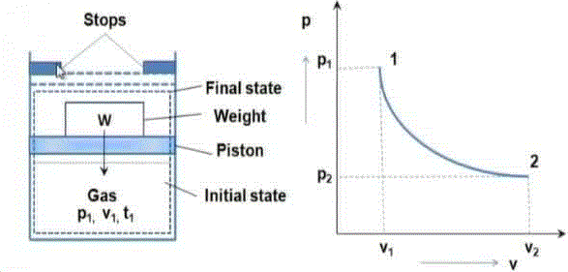

We will see one example for understanding the quasi static process, but let us consider one simple example for better understanding of quasi static process. If a person is coming down from roof to ground floor with the help of ladder steps then it could be considered as quasi static process. But if he jumps from roof to ground floor then it will not be a quasi static process.

Weight placed over the piston is just balancing the force which is exerted in upward direction by gas. If we remove the weight from the piston, system will have unbalanced force and piston will move in upward direction due to force acting over the piston in upward direction by the gas.

## Irreversible Process:

The irreversible process is also called the natural process because all the processes occurring in nature are irreversible processes. The natural process occurs due to the finite gradient between the two states of the system. For instance, heat flow between two bodies occurs due to the temperature gradient between the two bodies; this is in fact the natural flow of heat. Similarly, water flows from high level to low level, current moves from high potential to low potential, etc.

* In the irreversible process the initial state of the system and surroundings cannot be restored from the final state.
* During the irreversible process the various states of the system on the path of change from initial state to final state are not in equilibrium with each other.
* During the irreversible process the entropy of the system increases decisively and it cannot be reduced back to its initial value.
* The phenomenon of a system undergoing irreversible process is called as irreversibility.

## Causes of Irreversibility:

Friction: Friction is invariably present in real systems. It causes irreversibility in the process as work done does not show an equivalent rise in the kinetic or potential energy of the system. The fraction of energy wasted due to frictional effects leads to deviation from reversible states.

Free expansion: Free expansion refers to the expansion of unresisted type such as expansion in a vacuum. During this unresisted expansion the work interaction is zero, and without the expense of any work, it is not possible to restore initial states. Thus, free expansion is irreversible.

Heat transfer through a finite temperature difference: Heat transfer occurs only when there exist temperature difference between bodies undergoing heat transfer. During heat transfer, if heat addition is carried out in a finite number of steps then after every step the new state shall be a non-equilibrium state.

Nonequilibrium during the process: Irreversibilities are introduced due to lack of thermodynamic equilibrium during the process. Non-equilibrium may be due to mechanical inequilibrium, chemical inequilibrium, thermal inequilibrium, electrical inequilibrium, etc. and irreversibility is called mechanical irreversibility, chemical irreversibility, thermal irreversibility, electrical irreversibility respectively. Factors discussed above are also causing non-equilibrium during the process and therefore make process irreversible.

## Heat:

It is the energy in transition between the system and the surroundings by virtue of the difference in temperature Heat is energy transferred from one system to another solely by reason of a temperature difference between the systems. Heat exists only as it crosses the boundary of a system and the direction of heat transfer is from higher temperature to lower temperature. For thermodynamics sign convention, heat transferred to a system is positive; Heat transferred from a system is negative.

## Work:

Thermodynamic definition of work: Positive work is done by a system when the sole effect external to the system could be reduced to the rise of a weight.

Work done BY the system is positive and work done ON the system is negative.

## Types of work interaction:

* Expansion and compression work (displacement work)
* Work of a reversible chemical cell
* Work in stretching of a liquid surface
* Work done on elastic solids
* Work of polarization and magnetization

## Point and Path functions:

* Point function does not depend on the history (or path) of the system. It only depends on the state of the system.
* Examples of point functions are: temperature, pressure, density, mass, volume, enthalpy, entropy, internal energy etc.
* Path function depends on history of the system (or path by which system arrived at a given state).
* Examples for path functions are work and heat.
* Path functions are not properties of the system, while point functions are properties of the system.
* Change in point function can be obtained by from the initial and final values of the function, whereas path has to defined in order to evaluate path functions.

## Zeroth Law of Thermodynamics:

The Thermodynamics Zeroth Law states that if two systems are at the same time in thermal equilibrium with a third system, they are in equilibrium with each other.

If an object with a higher temperature comes in contact with an object of lower temperature, it will transfer heat to the lower temperature object. The objects will approach the same temperature and in the absence of loss to other objects, they will maintain a single constant temperature. Therefore, thermal equilibrium is attained.

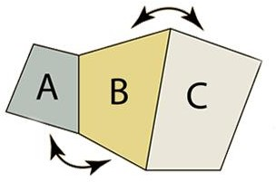

If objects ‘A’ and ‘C’ are in thermal equilibrium with ‘B’, then object ‘A’ is in thermal equilibrium with object ‘C’. Practically this means all three objects are at the same temperature and it forms the basis for comparison of temperatures.

## Principles of Thermometry:

Thermometry is the science and practice of temperature measurement. Any measurable change in a thermometric probe (e.g. the dilatation of a liquid in a capillary tube, variation of electrical resistance of a conductor, of refractive index of a transparent material, and so on) can be used to mark temperature levels, that should later be calibrated against an internationally agreed unit if the measure is to be related to other thermodynamic variables. Thermometry is sometimes split in metrological studies in two subfields: contact thermometry and noncontact thermometry. As there can never be complete thermal uniformity at large, thermometry is always associated to a heat transfer problem with some space-time coordinates of measurement, given rise to time-series plots and temperature maps.

## Constant Volume gas Thermometer:

When we heat a gas keeping the volume constant, its pressure increases and when we cool the gas its pressure decreases. The relationship between pressure and temperature at constant volume is given by the law of pressure. According to this law, the pressure of a gas changes by of its original pressure at 0oC for each degree centigrade (or Celsius) rise in temperature at constant volume.

If Po is the pressure of a given volume of a gas at 0oC and Pt is the pressure of the same volume of the gas (i.e., at constant volume) at toC, then

*Pt*  *Po* 

*P P* 

*Po*  *t*

273

(1 *t* )

*t*  *o*

273

It consists of a glass bulb B connected to a tube A, through a capillary glass tube ‘C’. The tube A is connected to a mercury reservoir R which is clamped on the board and can be lowered or raised whenever required to keep the volume of the air constant. The capillary tube C is provided with a three way stopper S and can be used to connect capillary and bulb as well as to disconnect tube from bulb B. A pointer is provided such that the end P is projecting inside from the upper part of A. A scale calibrated in 0oC is provided between A and R.

The whole apparatus is leveled by adjusting the leveling screws. By adjusting the stopper, the bulb ‘B’ is filled with air or some gas and the pointer is adjusted so that tip of the pointer just touches the level of mercury in the tube A. After filling the bulb, it is kept in an ice bath for some time till the air inside the bulb attains the temperature of ice at which the mercury level becomes stationary. Now the reservoir R is adjusted so that the level of mercury in the tube A just touches the tip of the pointer P.

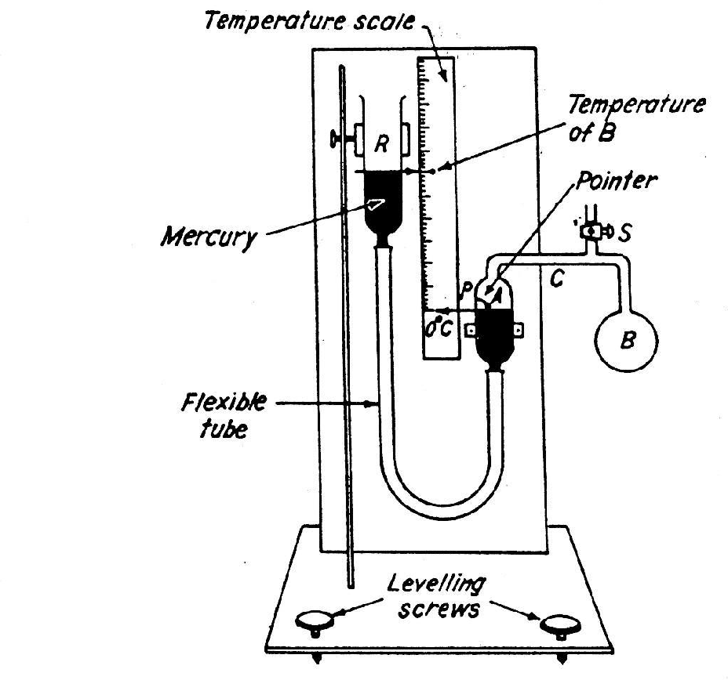

The difference between the mercury levels in the two tubes is noted and let it be ho. If Po is the pressure exerted by the air in the bulb, then

*Po*  *P*  *h*0

Now ice bath is removed and the bulb B is surrounded with steam.

## Scales of Temperature:

There are three temperature scales in use Fahrenheit, Celsius and Kelvin. Fahrenheit temperature scale is a scale based on 32 for the freezing point of water and 212 for the boiling point of water, the interval between the two being divided into 180 parts.

The conversion formula for a temperature that is expressed on the Celsius (C) scale to its Fahrenheit (F) representation is: F = 9/5C + 32.

Celsius temperature scale also called centigrade temperature scale, is the scale based on 0 for the freezing point of water and 100 for the boiling point of water.

Kelvin temperature scale is the base unit of thermodynamic temperature measurement in the International System (SI) of measurement. It is defined as 1/ 273.16 of the triple point (equilibrium among the solid, liquid, and gaseous phases) of pure water.

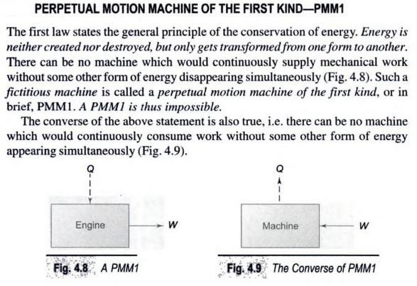

## Joule experiment:

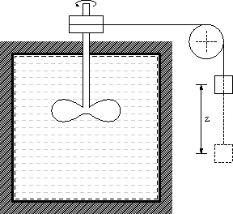

James P. Joule carried out his famous experiment; he placed known amounts of water, oil, and mercury in an insulated container and agitated the fluid with a rotating stirrer. The amounts of work done on the fluid by the stirrer were accurately measured, and the temperature changes of the fluid were carefully noted. He found for each fluid that a fixed amount of work was required per unit mass for every degree of temperature rise caused by the stirring, and that the original temperature of the fluid could be restored by the transfer of heat through simple contact with a cooler object. In this experiment you can conclude there is a relationship between heat and work or in other word heat is a form of energy.

## Internal Energy

Through, Joule experiment what happen to energy between time it is added to water as work, and time it is extracted to heat? Logic suggests that this energy contained in the water in another form which called internal energy.

Internal energy refers to energy of molecules of substance which are ceaseless motion and possess kinetics energy. The addition of heat to a substance increases this molecular activity, and thus causes an increase in its internal energy. Work done on the substance can have the same effect, as was shown by Joule. Internal energy cannot be directly measured; there are no internal-energy meters. As a result, absolute values are unknown. However, this is not a disadvantage in thermodynamic analysis, because only changes in internal energy are required.

## First Law of Thermodynamics:

During a thermodynamic cycle, a cyclic process the systems undergoes, the cyclic integral of heat added is equal to integral of work done. The first law equation can also be written in the form,

§(dQ – dW) = 0

Equation dU = dQ – dW is a corollary to the first law of thermodynamics. It shows that there exists a property internal energy (U) of the system, such that a change in its value is equal to the difference in heat entering and work leaving the system.

The First law of thermodynamics states that energy is neither created nor destroyed. Thus the total energy of the universe is a constant. However, energy can certainly be transferred from one form to another form.

The 1st law of thermodynamics can be mathematically stated as follows:

§dQ = §dW

## Corollary 1:

There exists property of closed system; the change in value of this property during the process is given by the difference between heat supplied and work done.

dU = dQ - dW

Here E is property of system and is called as total energy that includes internal energy, kinetic energy, potential energy, electrical energy, magnetic energy, chemical energy, etc.

## Corollary 2:

For the isolated system, heat and work both interactions are absent (d Q = 0, d W = 0) and E = constant. Energy can neither be created nor be destroyed; but, it can be converted from one form to other.

## Corollary 3:

A perpetual motion machine of first kind is almost impossible.

## Flow Process

Steady flow energy equation:

Virtually all the practical systems involve flow of mass across the boundary separating the system and the surroundings. Whether it be a steam turbine or a gas turbine or a compressor or an automobile engine there exists flow of gases/gas mixtures into and out of the system. So we must know how the first Law of thermodynamics can be applied to an open system.

The fluid entering the system will have its own internal, kinetic and potential energies.

Let u1 be the specific internal energy of the fluid entering C1 be the velocity of the fluid while entering Z1 be the potential energy of the fluid while entering Similarly let u2, C2 and Z2 be respective entities while leaving.

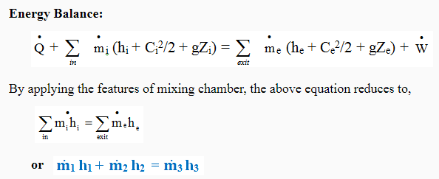

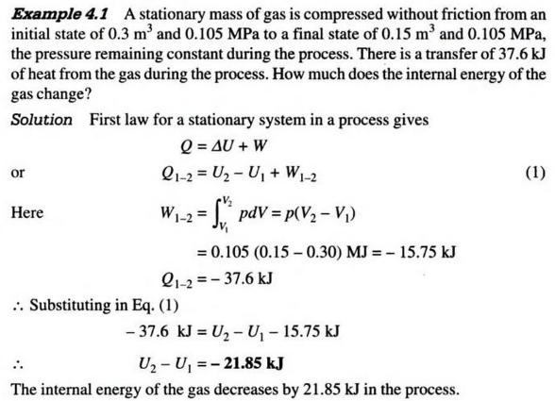

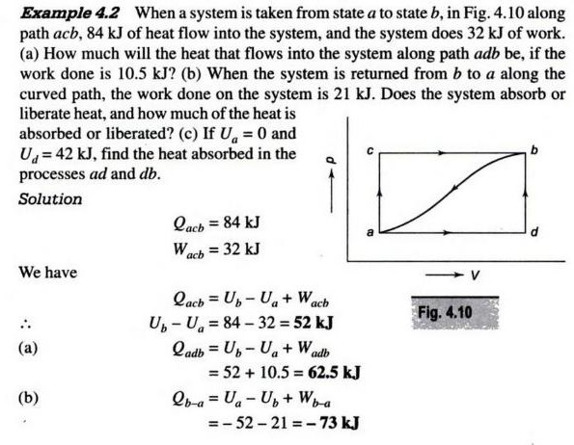

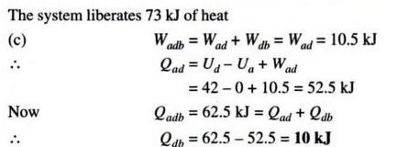

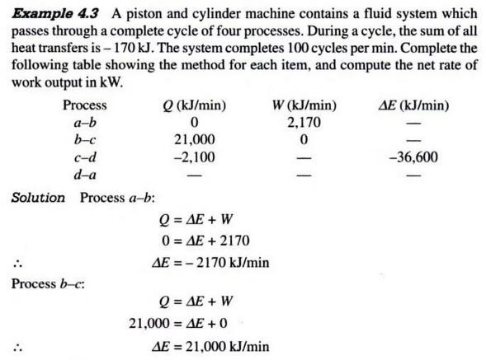

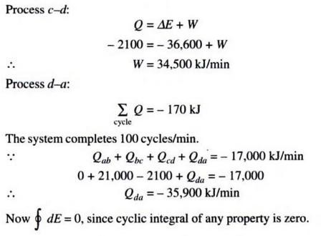

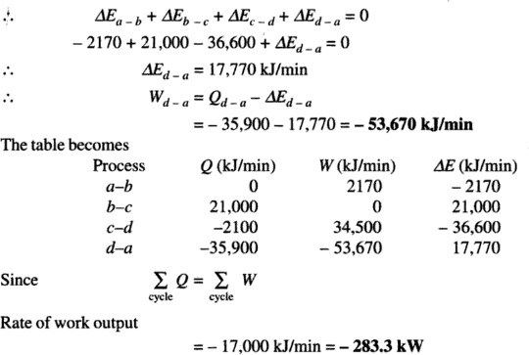

# UNIT-II

## Limitations of the First Law:

* The first law of thermodynamics merely indicates that in any process there is a transformation between the various forms of energy involved in the process but provides no information regarding the feasibility of such transformation.
* First law does not provide any information regarding the direction processes will take

whether it is a spontaneous or a non spontaneous process.

## Thermal Reservoir:

A thermal reservoir is a large system (very high mass x specific heat value) from which a quantity of energy can be absorbed or added as heat without changing its temperature. The atmosphere and sea are examples of thermal reservoirs. Any physical body whose thermal energy capacity is large relative to the amount of energy it supplies or absorbs can be modelled as a thermal reservoir. A reservoir that supplies energy in the form of heat is called a source and one that absorbs energy in the form of heat is called a sink.

## Heat Engine:

It is a cyclically operating device which absorbs energy as heat from a high temperature reservoir, converts part of the energy into work and rejects the rest of the energy as heat to a thermal reservoir at low temperature.

The working fluid is a substance, which absorbs energy as heat from a source, and rejects energy as heat to a sink.

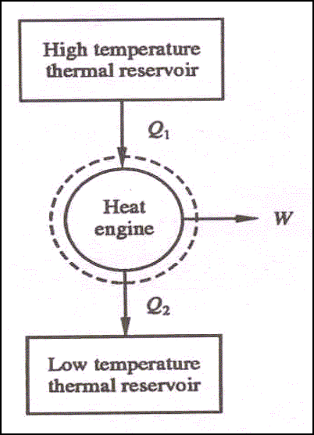

## Schematic representation of Heat Engine

**Heat pump:**

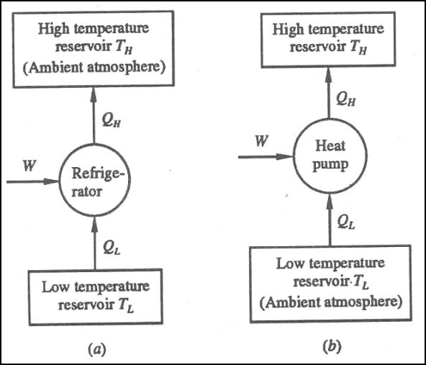A heat pump is a device that transfers heat energy from a source of heat to what is called a heat sink. Heat pumps move thermal energy in the opposite direction of spontaneous heat transfer, by absorbing heat from a cold space and releasing it to a warmer one. A heat pump uses a small amount of external power to accomplish the work of transferring energy from the heat source to the heat sink. The most common design of a heat pump involves four main components – a condenser, an expansion valve, an evaporator and a compressor. The heat transfer medium circulated through these components is called refrigerant.

## Schematic representation of Heat Pump Coefficient of Performance

The coefficient of performance, COP, of a refrigerator is defined as the heat removed from the cold reservoir Qcold, (i.e. inside a refrigerator) divided by the work W done to remove the heat (i.e. the work done by the compressor).

COP - coefficient of performance - equation

As can be seen, the better (more efficient) the refrigerator is when more heat Qcold can be removed from the inside of the refrigerator for a given amount of work. Since the first law of thermodynamics must be valid also in this case (Qcold + W = Qhot), we can rewrite the above equation:

The COP for heating and cooling are thus different, because the heat reservoir of interest is different. When one is interested in how well a machine cools, the COP is the ratio of the heat removed from the cold reservoir to input work. However, for heating, the COP is the ratio of the heat removed from the cold reservoir plus the input work to the input work: medium to a high-temperature is called heat pump.

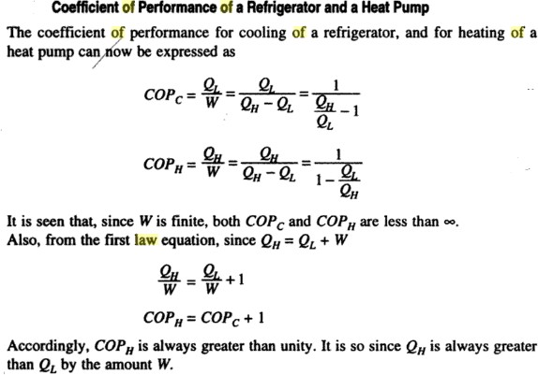

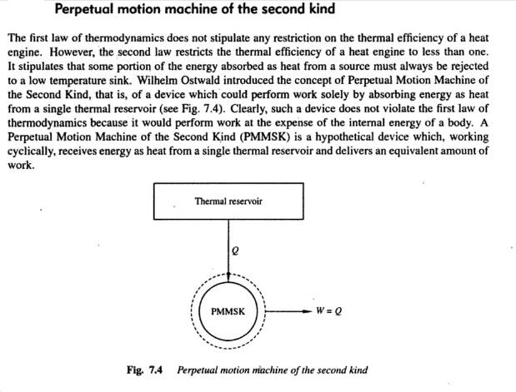

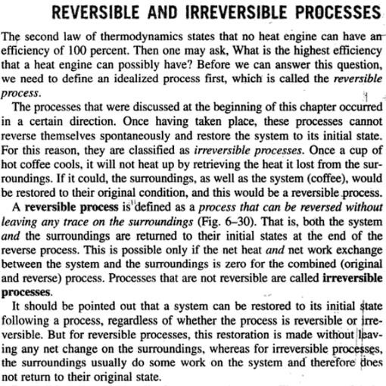

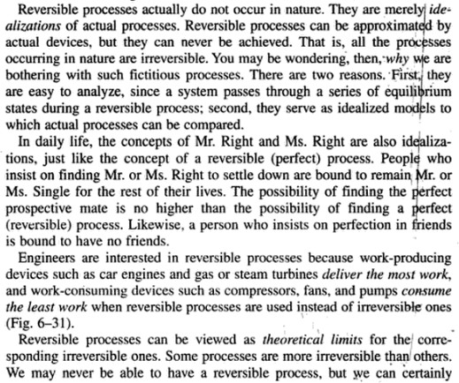

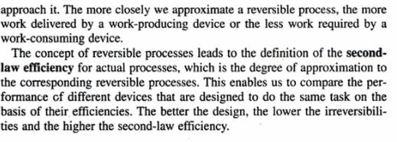

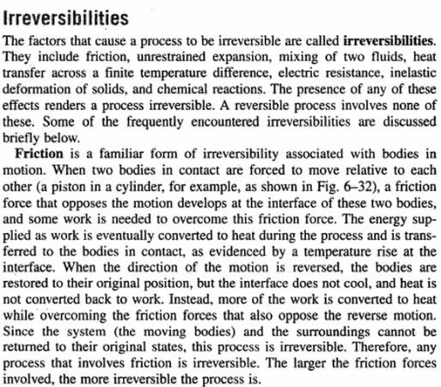

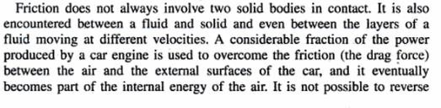

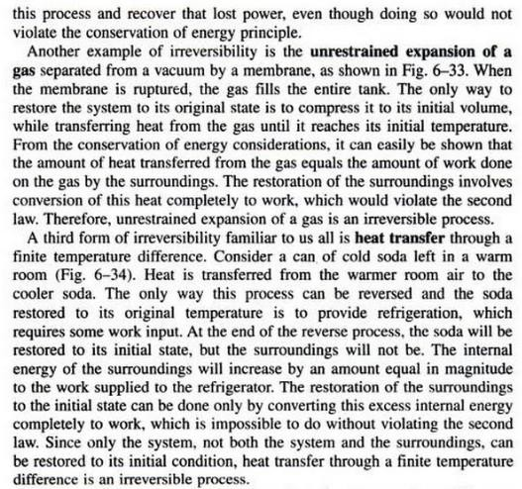

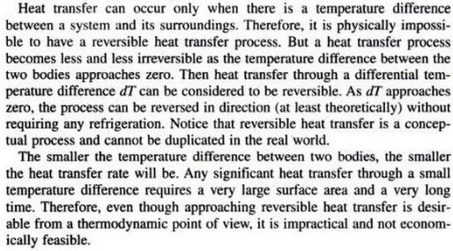

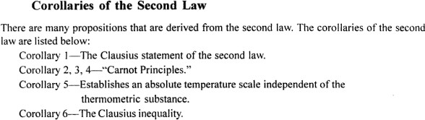



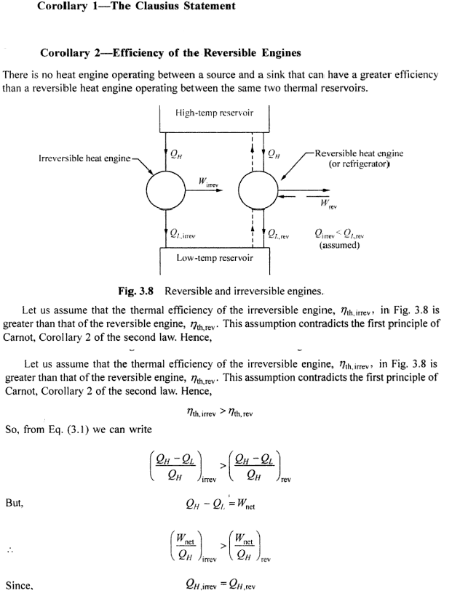

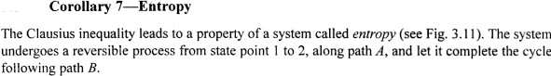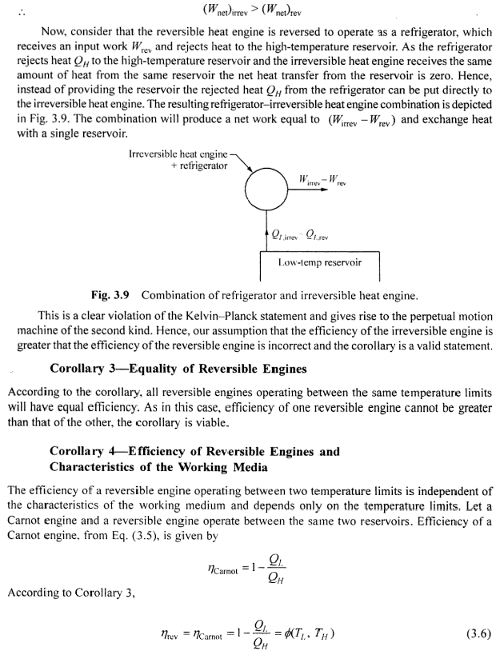

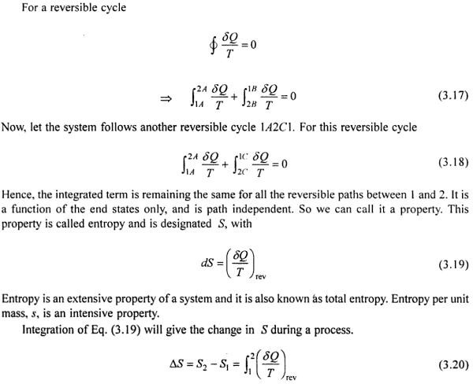

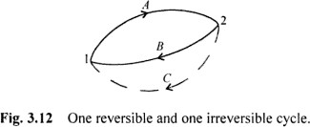

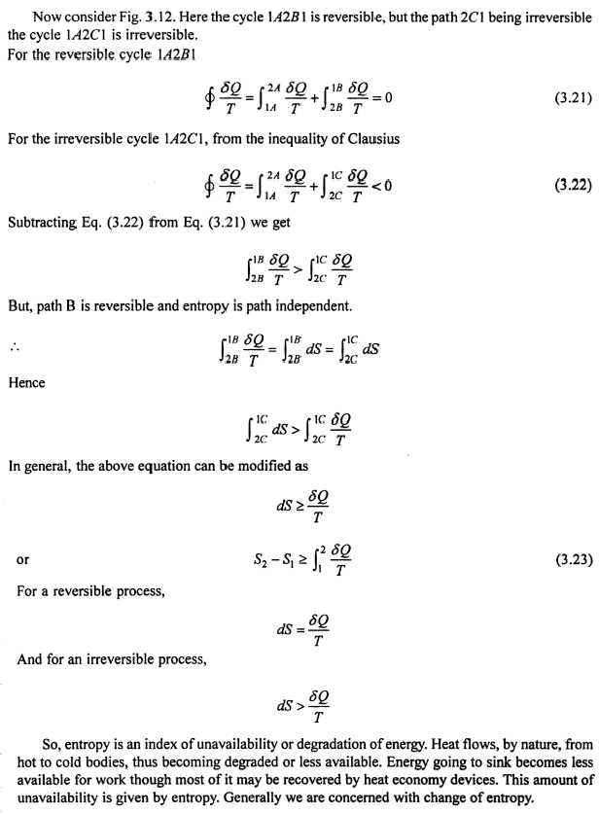

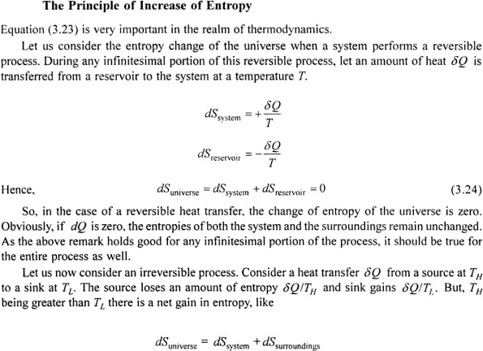

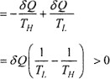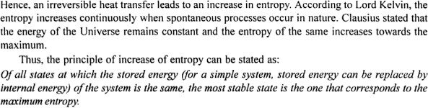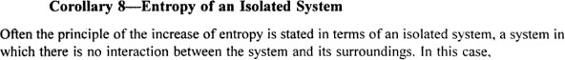

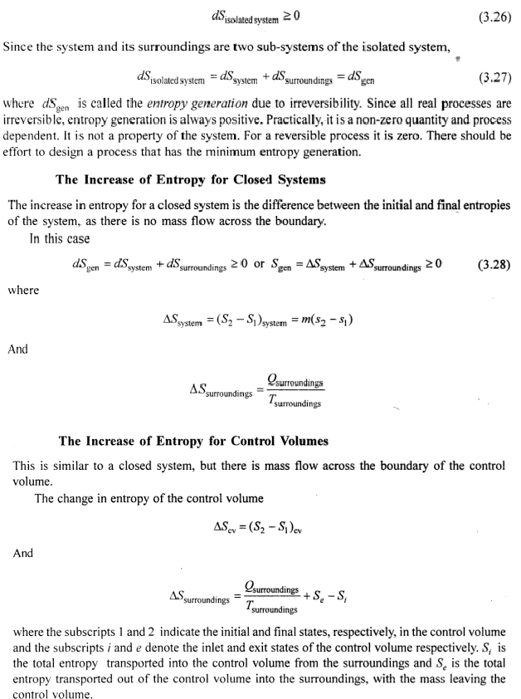

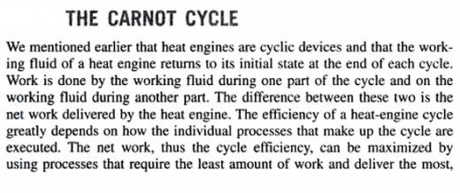

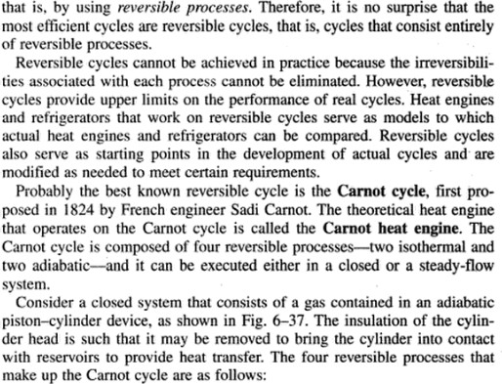

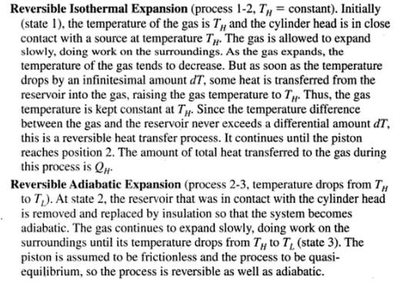

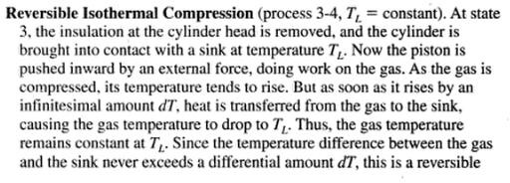

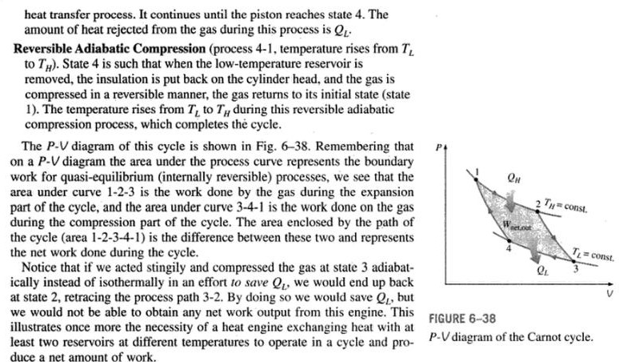

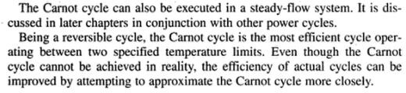

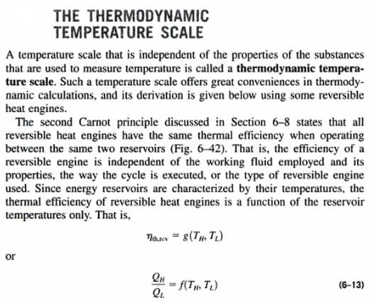

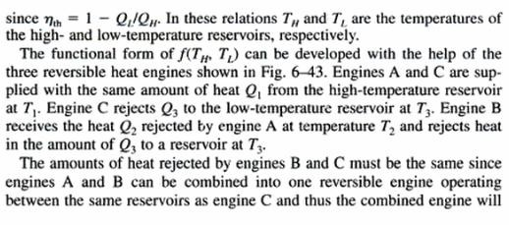

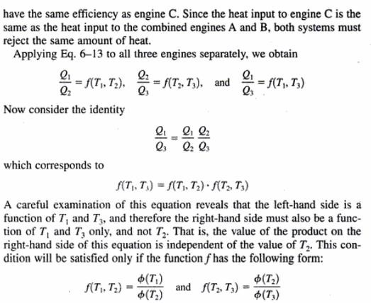

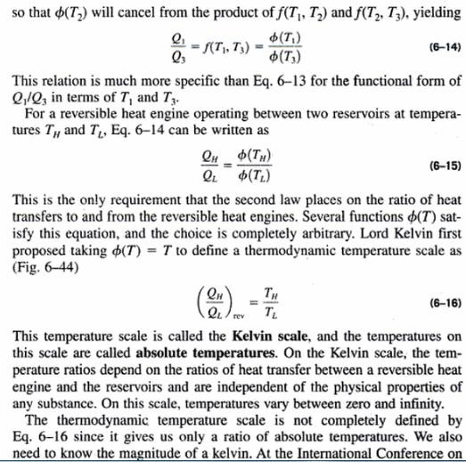

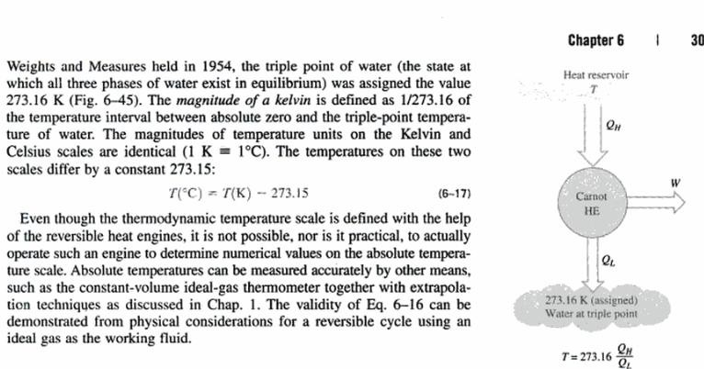

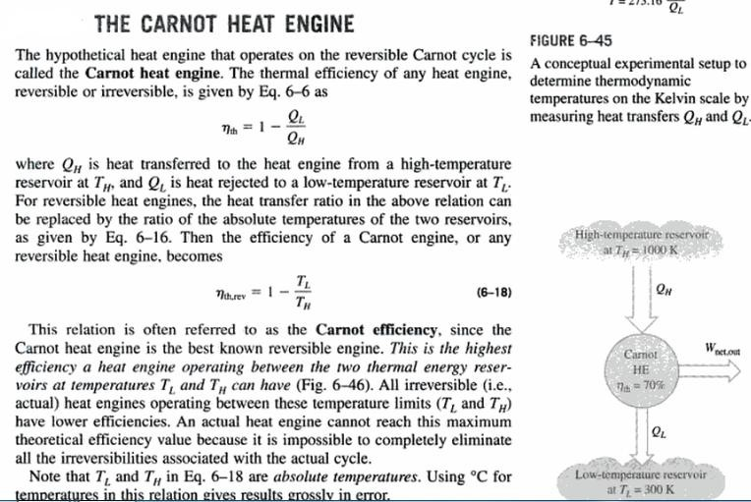

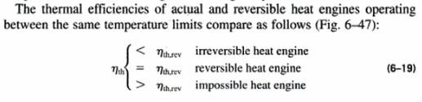

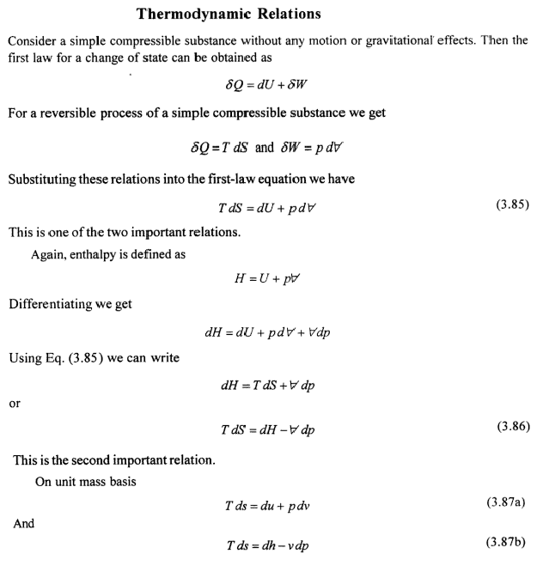

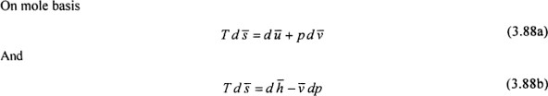

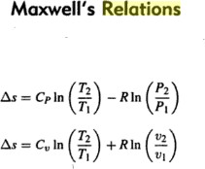

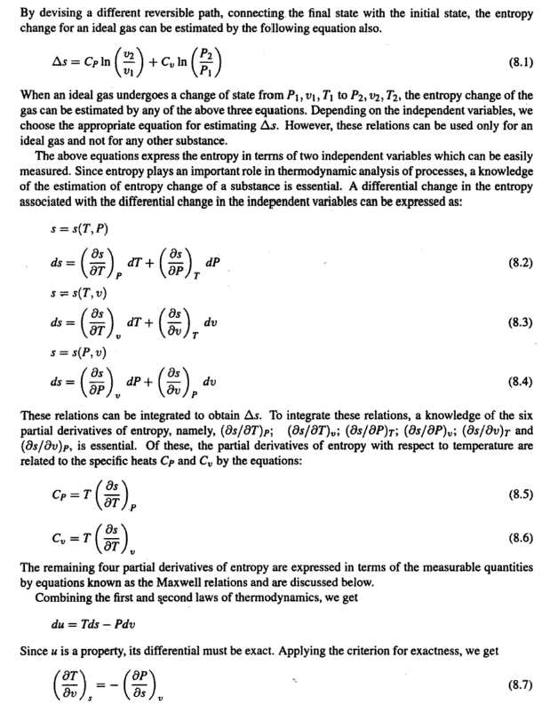

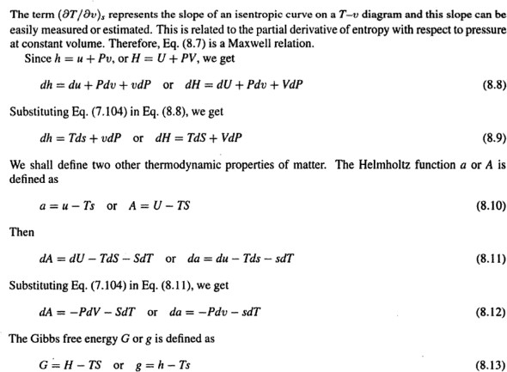

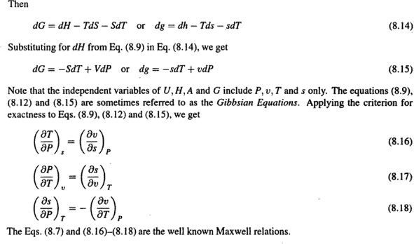

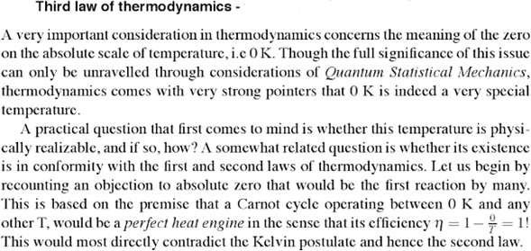

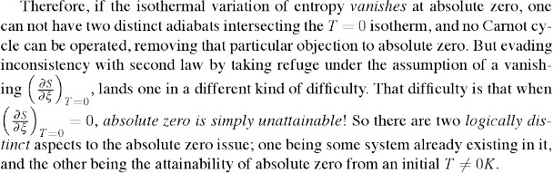

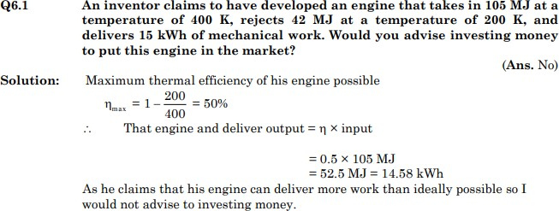

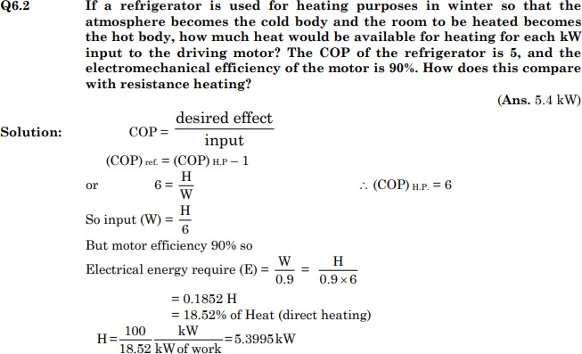

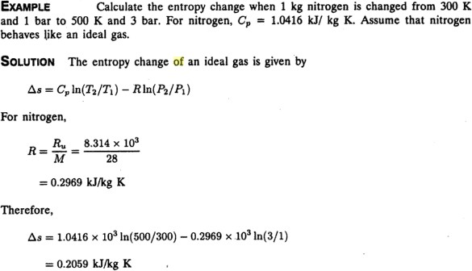

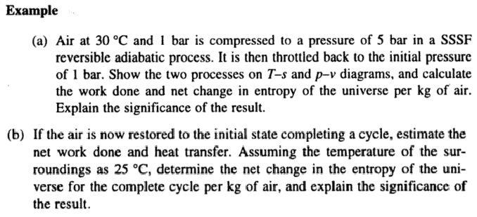

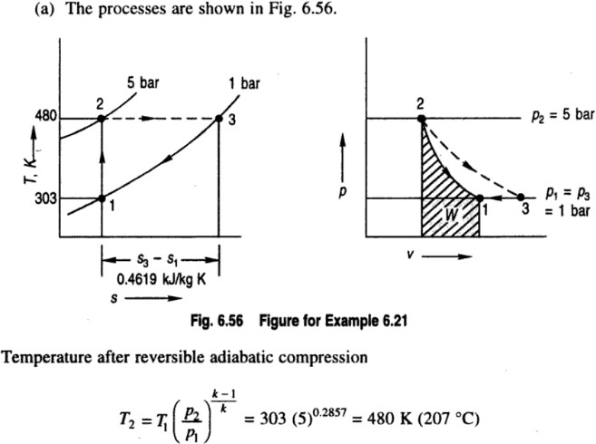

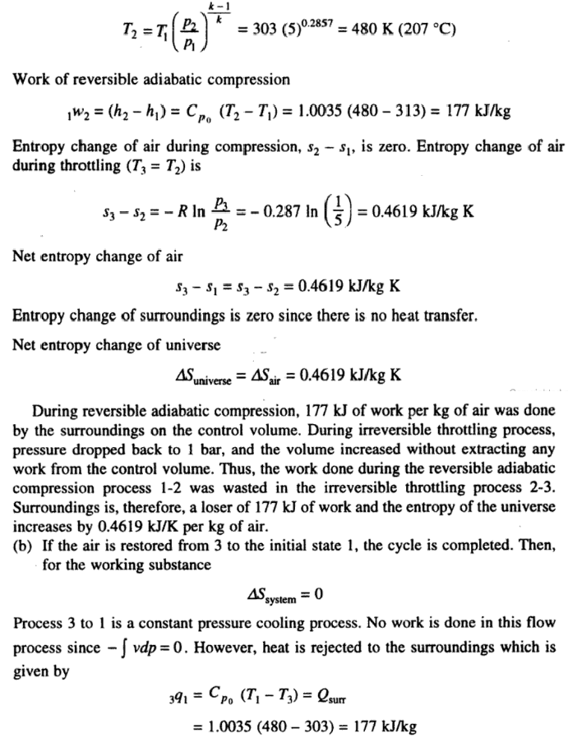

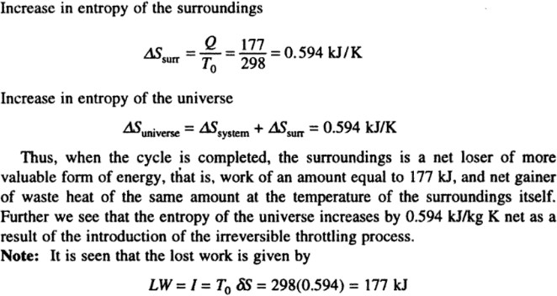

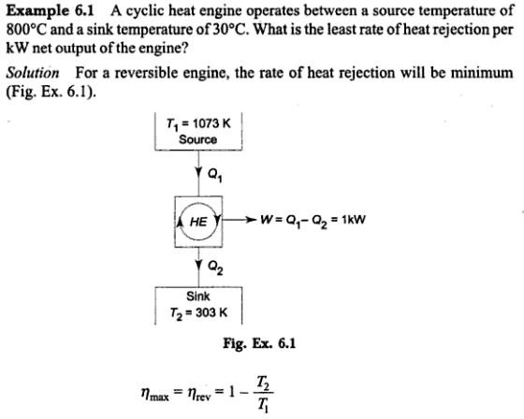

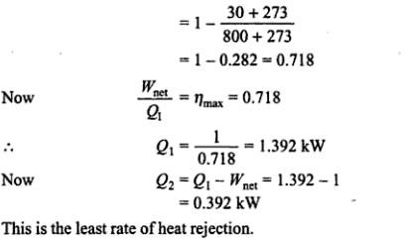

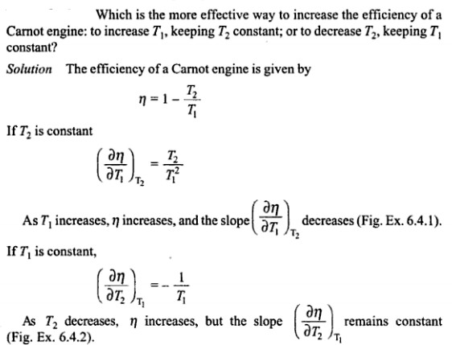

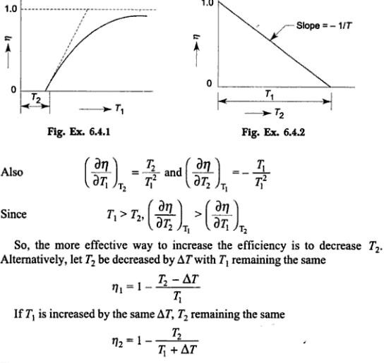

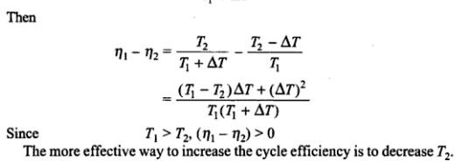

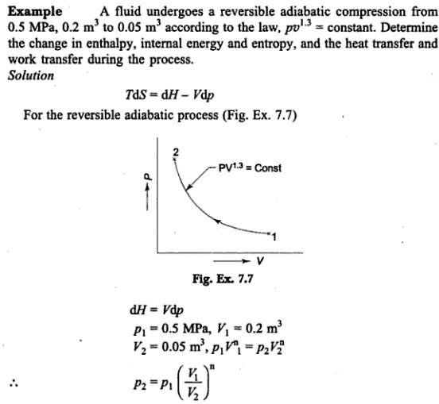

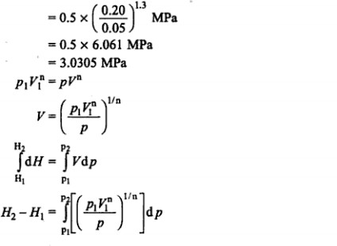

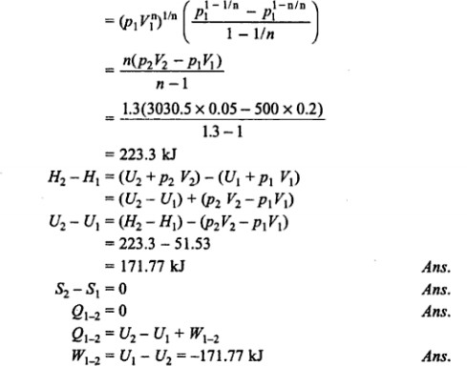

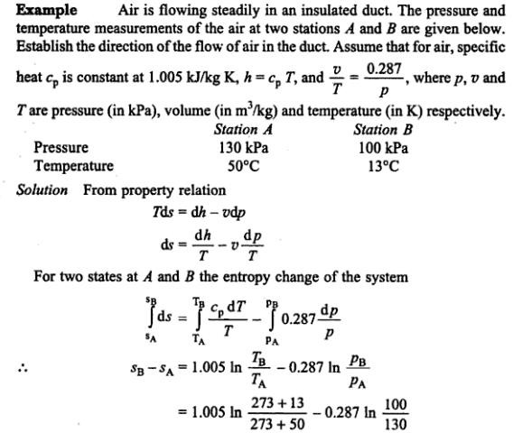

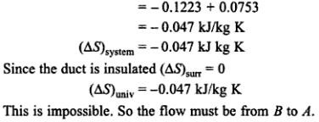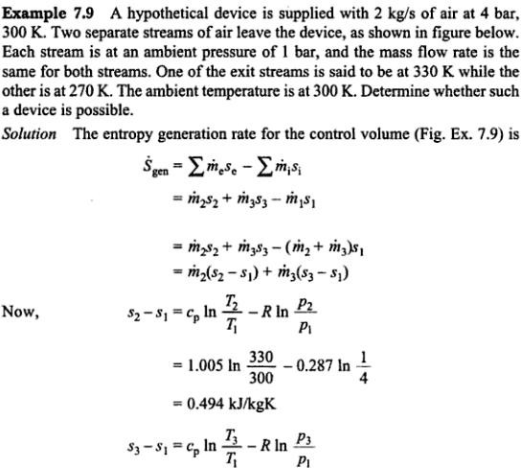

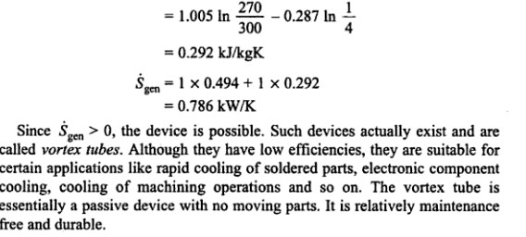

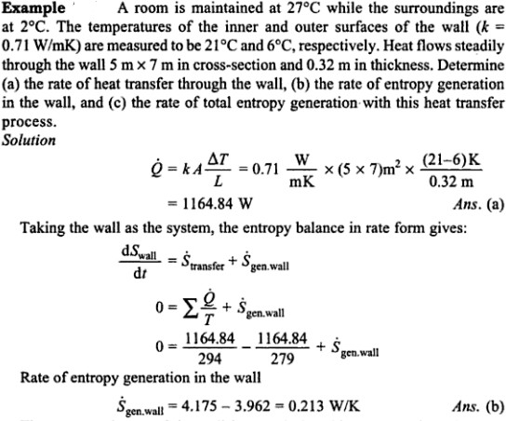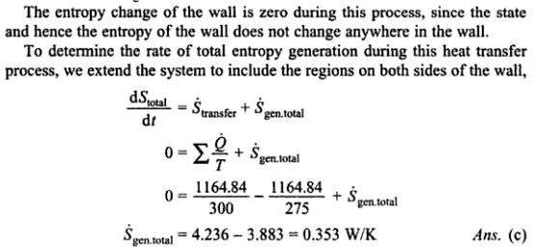

## UNIT -III

**Pure substance**

A substance that has a fixed chemical composition throughout the system is called a pure substance. Water, hydrogen, nitrogen, and carbon monoxide, for example, are all pure substance. A pure substance can also be a mixture of various chemical elements or compounds as long as the mixture is homogeneous. Air, a mixture of several compounds, is often considered to be a pure substance because it has a uniform chemical composition. “A mixture of two or more phases of a pure substance is still a pure substance as long as the chemical composition of all phases is the same. A mixture of ice and liquid water, for example, is a pure substance because both phases have the same chemical composition.”

## PVT Surface

Pressure can be expressed as a function of temperature and specific volume: *p = p*(*T*, *v*). The plot of *p = p*(*T*, *v*) is a surface called *p-v-T* surface. Figure 3.1 shows the *p-v-T* surface of a substance such as water that expands on freezing.

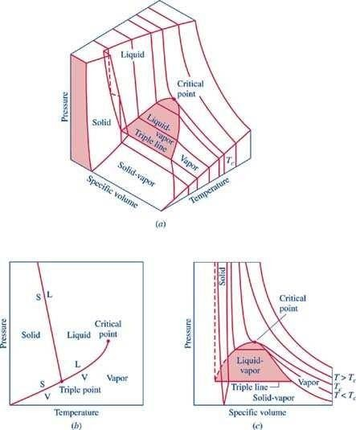

**Figure 3.1** *p-v-T* surface and projections for a substance that expands on freezing.

1. 3-D view (b) *p-T* diagram (c) *p-v* diagram2.

The location of a point on the *p-v-T* surface gives the values of pressure, specific volume, and temperature at equilibrium. The regions on the *p-v-T* surface labeled *solid*, *liquid*, and *vapor* are single-phase regions. The state of a single phase is determined by any two of the properties: pressure, temperature, and specific volume. The two-phase regions where two phases exist in equilibrium separate the single-phase regions. The two-phase regions are: liquid-vapor, solid-liquid, and solid-vapor. Temperature and pressure are dependent within the two-phase regions. Once the temperature is specified, the pressure is determined and vice versa. The states within the two-phase regions can be fixed by specific volume and either temperature or pressure.

The projection of the *p-v-T* surface onto the *p-T* plane is known as the phase diagram as shown in Figure 3.1 (b). The two-phase regions of the *p-v-T* surface reduce to lines in the phase diagram. A point on any of these lines can represent any two-phase mixture at that particular temperature and pressure. The triple line of the *p-v-T* surface projects onto a point on the phase diagram called the triple point. Three phases coexist on the triple line or the triple point.

The constant temperature lines of the *p-v* diagram are called the isotherms. For any specified temperature less than the critical temperature, the pressure remains constant within the two- phase region even though specific volume changes. In the single-phase liquid and vapor regions the pressure decreases at fixed temperature as specific volume increases. For temperature greater than or equal to the critical temperature, there is no passage across the two-phase liquid-vapor region.

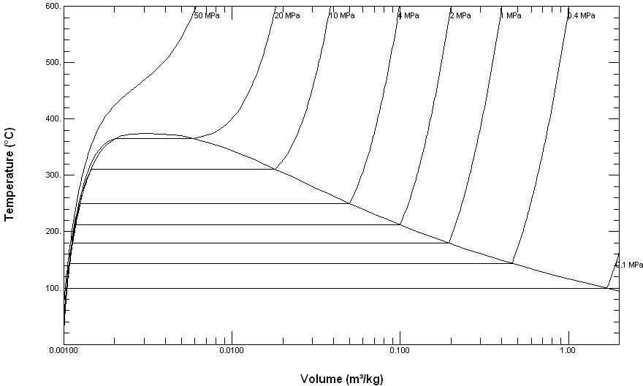

**Figure 3.1-2** *T-v* diagram for water (to scale).

Figure 3.1-2 is a *T-v* diagram for water. For pressure greater than or equal to the critical pressure, temperature increases continously at fixed pressure as the specific volume increases and there is no passage across the two-phase liquid-vapor region. The isobaric curve marked 50 MPa in Figure 3.1-2 shows this behavior. For pressure less than the critical value, there is a two-phase region where the temperature remains constant at a fixed pressure as the two- phase region is traversed. The isobaric curve with values of 20 MPa or less in Figure 3.1-2 shows the constant temperature during the phase change.

At 100oC, the saturated volumes of liquid and vapor water are 1.0434 cm3/g and 1,673.6 cm3/g, respectively. The quality of steam is the mass fraction of water vapor in a mixture of liquid and vapor water. The specific volume of 100oC steam with a quality of 0.65 is given by

*v* = (1 - 0.65)*v*L + 0.65 *v*V = (0.35)(1.0434) + (0.65)(1,673.6) = 1088.2 cm3/g

## Phase Behavior:

We will consider a phase change of 1 kg of liquid water contained within a piston-cycinder assembly as shown in Figure 3.2-1a. The water is at 20oC and 1.014 bar (or 1 atm) as indicated by point (1) on Figure 3.2-2.

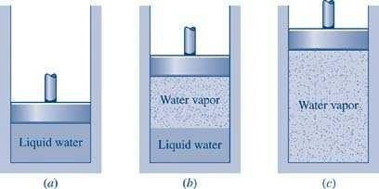

**Figure 3.2-1** Phase change at constant pressure for water3

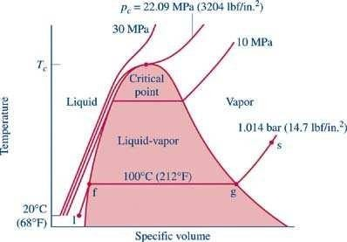

**Figure 3.2-2** Sketch of *T-v* diagram for water

As the water is heated at constant pressure, the temperature increases with a slight increase in specific volume until the system reaches point (f). This is the

saturated liquid state corresponding to 1.014 bar. The saturation temperature for water at 1.014 bar is 100oC. The liquid states along the line segment 1-f are called *subcooled* or *compressed* liquid states. When the system is at the saturated liquid state (point f in Figure 3.2-2) any additional heat will cause the liquid to evaporate at constant pressure as shown in Figure 3.2-1b. When a mixture of liquid and vapor exists in equilibrium, the liquid phase is a saturated liquid and the vapor phase is a saturated vapor.

Liquid water continues to evaporate with additional heat until it becomes all saturated vapor at point (g). Any further heating will cause an increase in both temperature and specific volume and the saturated vapor becomes superheated vapor denoted by point (s) in Figure 3.2-2. For a two-phase liquid-vapor mixture, the quality *x* is defined as the mass fraction of vapor in the mixture

x = mvapor mvapor + mliquid

When a substance exists as part liquid and part vapor at saturation conditions, its quality (x) is defined as the ratio of the mass of the vapor to the total mass of both vapor and liquid.

## Enthalpy–Entropy Chart

An enthalpy–entropy chart, also known as the H–S chart or Mollier diagram, plots the total heat against entropy, describing the enthalpy of a thermodynamic system. A typical chart covers a pressure range of 0.01–1000 bar, and temperatures up to 800 degrees Celsius. It shows enthalpy H in terms of internal energy U, pressure p and volume V using the relationship H=U+pV or, in terms of specific enthalpy, specific entropy and specific volume.

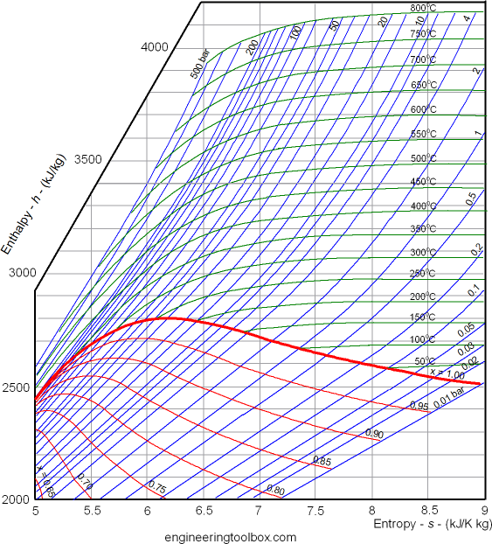

On the diagram, lines of constant pressure, constant temperature and volume are plotted, so in a two-phase region, the lines of constant pressure and temperature coincide. Thus, coordinates on the diagram represent entropy and heat.

A vertical line in the h–s chart represents an isentropic process. The process 3–4 in a Rankine cycle is isentropic when the steam turbine is said to be an ideal one. So the expansion process in a turbine can be easily calculated using the h–s chart when the process is considered to be ideal (which is the case normally when calculating enthalpies, entropies, etc. Later the deviations from the ideal values and they can be calculated considering the isentropic efficiency of the steam turbine used.

Lines of constant dryness fraction (x), sometimes called the quality, are drawn in the wet region and lines of constant temperature are drawn in the superheated region. X gives the

fraction (by mass) of gaseous substance in the wet region, the remainder being colloidal liquid droplets. Above the heavy line, the temperature is above the boiling point, and the dry (superheated) substance is gas only.

## Characteristics of the critical point:

* For saturated phase often its enthalpy is an important property.
* Enthalpy-pressure charts are used for refrigeration cycle analysis.
* Enthalpy-entropy charts for water are used for steam cycle analysis.
* Note: Unlike pressure, volume and temperature which have specified numbers associated with it, in the case of internal energy, enthalpy (and entropy) only changes are required. Consequently, a base (or datum) is defined -as you have seen in the case of water.

Let V be total volume of liquid vapour mixture of quality x, Vfthe volume of saturated liquid and Vg the volume of saturated vapour, the corresponding masses being m, mf and mg respectively.

Now, m = mf + mg V = Vf+ Vg

m v= mfvf+ mgvg

## Saturation States

When a liquid and its vapour are in equilibrium at certain pressure and temperature, only the pressure or the temperature i is s sufficient to identify the saturation state.

If pressure is given, the temperature of the mixture gets fixed, which is known as saturation temperature, or if the temperature is given, the saturation pressure gets fixed.

Saturation liquid or saturated vapour has only on independent variable, i.e. only one property is required to b known to fix up the state.

## Type of Steam

Wet steam:

Wet steam is defined as steam which is partly vapour and partly liquid suspended in it. It means that evaporation of water is not complete.

Dry saturated steam:

When the wet steam is further heated, and it does not contain any suspended particles of water, it is known as dry saturated steam.

Superheated steam: When the dry steam is further heated at constant pressure, thus raising its temperature, it is called superheated steam.

## Measurement of Steam Quality:

The state of a pure substance gets fixed if two independent properties are given. A pure substance is thus said to have two degrees of freedom. Of all thermodynamic properties, it

is easiest to measure the pressure and temperature of a substance. Therefore, whenever pressure and temperature are independent properties, it is the practice to measure them to determine that state of the substance.

Types of Calorimeters used for measurement of Steam Quality

* Barrel Calorimeter
* Separating Calorimeter
* Throttling Calorimeter
* Combined Separating and Throttling calorimeter

## Barrel Calorimeter

Dryness fraction of steam can be found out very conveniently by barrel calorimeter as shown in figure. A vessel contains a measured quantity of water. Also water equivalent of the vessel is determined experimentally and stamped platform of weighing machine.

Sample of steam is passed through the sampling tube into fine exit holes for discharge of steam in the cold water.

The steam gets condensed and the temperature of water rises. The weighing machine gives the steam condensed.

*HeatLost*  *HeatGain*

*m*{*x hfg* (*ts* *t*2)}*Cp*

*M* (*t*2

*x* 

*Cp*{*M m*(*t*2 *t*1)(*ts* *t*2)}

*hfg*

From the law of conservation of energy,

Where, x = quantity of steam in the main pipe hfg = latent heat of vaporization at pressure p

Cp = specific heat of water at constant pressure p m = mass of steam condensed

M =Equivalent mass of water at commencement tS =Sat. temperature;

t1 = temperature of Water at commencement

t2 = final temperature after steam has condensed

## Separating Calorimeter

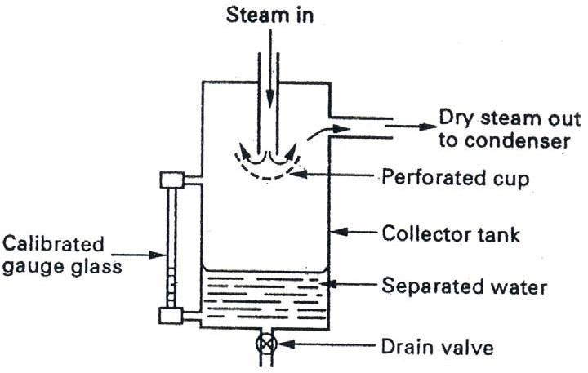

The wet steam enters at the top from the main steam pipe through holes in the sampling pipe facing up stream which should be as far as possible downstream from elbows and valves to ensure representative sample of steam when in operation the wet steam entering passes down the central passage and undergoes a sudden reversal of direction of motion when strikes perforated cup.

Advantages:

Quick determination of dryness fraction of very wet steam Disadvantages:

It leads to inaccuracy due to incomplete separation of water

Dryness fraction calculated is always greater than actual dryness fraction.

## Throttling Calorimeter

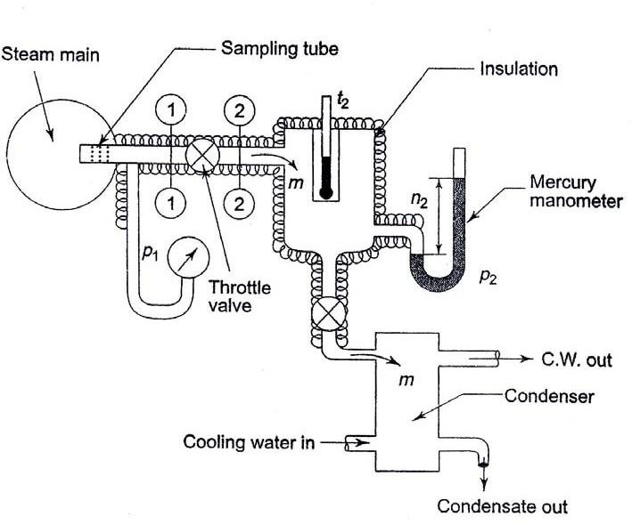

In the throttling calorimeter, a sample of wet steam of mass m and at pressure P1 is taken from the steam main through a perforated sampling tube. Then it is throttled by the partially-opened valve (or orifice) to a pressure P2 measured by mercury manometer, and temperature t2, so that after throttling the steam is in the superheated region.

The steady flow energy equation gives the enthalpy after throttling as equal to enthalpy before throttling. The initial and final equilibrium states 1 and 2 are joined by a dotted line since throttling is irreversible (adiabatic but not isentropic) and the intermediate states are non-equilibrium states not describable by thermodynamic coordinates. The initial state (wet) is given by P1and x1 and the final state by P2 and t2.

Advantages:

Dryness fraction of very dry steam can be found out easily.

Disadvantages:

It is not possible to find dryness fraction of very wet steam.

## Combined Separating and Throttling calorimeter

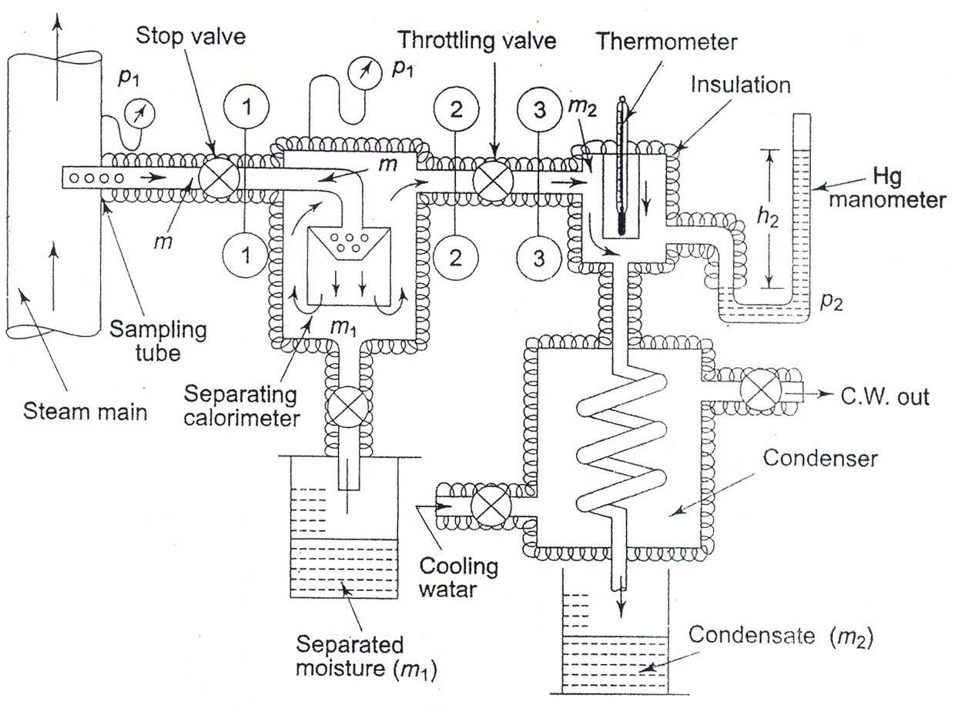

When the steam is very wet and the pressure after throttling is not low enough to take the steam to the superheated region, then a combined separating and throttling calorimeter is used for the measurement of quality.

Steam from the main is first passed through a separator where some part of the moisture separates out due to the sudden change in direction and falls by gravity, and the partially dry vapour is then throttled and taken to the superheated region.

1. Calculate the dryness fraction of steam which has 1.5 kg of water in suspension with 50

kg of steam.

Given

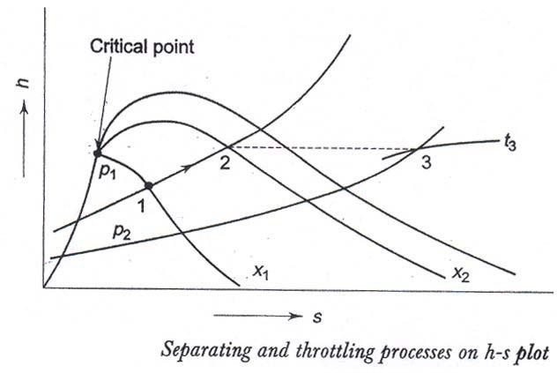

In Fig. process 1-2 represents the moisture separation from the wet sample of steam at constant pressure P1 and process 2-3 represents throttling to pressure P2. With P2 and t3 being measured, h3 can be found out from the superheated steam table.

*h*3  *h*2  *hf*

*p*1

* *x h*

2 *fg*

*p*1

Therefore x2, the quality of steam after partial moisture separation can be evaluated If m kg of steam, is taken through the sampling tube in t s, m1 kg of it is separated, and m2 kg is throttled and then condensed to water and collected, then m = m1 + m2 and at state 2, the mass of dry vapour will be x2 m2. Therefore, the quality of the

sample of steam at state l, x1 is given by . .

*x* 

*massof dry vapour state*1

1

*massof liquid*  *vapour mixtureat state*1 *x*

2

*m*2



*m*1  *m*2

Mass of water (mf) = 1.5 kg Mass of steam (mg) = 50 kg

Required : Dryness fraction (x) Solution

m

g Dryness fraction (x) = -

mg + mf

50

= -------------- = **0.971 Ans**

50 1.5

Eg. Steam is generated at 8 bar from water at 32oC. Determine the heat required to produce 1 kg of steam (a) when the dryness fraction is 0.85 (b) when steam is dry saturated and (c) when the steam is superheated to 305oC. The specific heat of superheated steam may be taken as 2.093 kJ/kg-K.

*Given:*

Steam pressure (p) = 8 bar

Initial temperature of water (T1) = 32oC Mass of steam (m) = 1 kg

*Required*: Heat required when (a) x =

0.85 (b) x = 1 (c) Tsup = 305oC

*Solution:*(a)

SH LH

T 170.4

32oC



Heat added

Heat required = Sensible heat addition + Latent heat addition Sensible heat addition = m Cpw (ts – T1) ts = saturation temperature = 170.4oC at 8 bar

from steam table Cpw = Specific heat at constant pressure = 4.186 kJ/kg (Taken)

Sensible Heat addition = 1 x 4.186 x (170.4 – 32)

= 79.34 kJ/kg

Latent heat addition / kg = x hfg

Latent heat (hfg) = 2046.5 kJ/kg from steam table at 8 bar Latent heat addition for ‘m’ kg = m x hfg

= 1 x 0.85 x (2046.5)

= 1739.525 kJ/kg

Total heat required = 579.34 + 1739.525

= 2318.865 kJ/kg --- Ans

1. (b)

SH

LH

T

170.4oC

Heat required = Sensible heat addition + Latent heat addition Latent heat addition / kg = x hfg

Latent heat (hfg) = 2046.5 kJ/kg from steam table at 8 bar Latent heat addition for ‘m’ kg = m x hfg

= 1 x 1 x (2046.5)

= 2046.5 kJ/kg Total heat required = 579.34 + 2046.5

## = 2625.84 kJ/kg --- Ans

Heat required = Sensible heat addition + Latent heat addition + Sensible Heat addition Sensible heat addition to superheated steam

= m Cpv (Tsup – ts)

= 1 x 2.093 x (305 – 170.4)

= 281.72 kJ/kg

Latent heat addition / kg = hfg

Latent heat (hfg) = 2046.5 kJ/kg from steam table at 8 bar Total heat required = 579.34 + 2046.5 + 281.72

## = 2907.56 kJ/kg --- Ans

**Ideal Gas:**

Perfect gas, also called ideal gas, a gas that conforms, in physical behaviour, to a particular, idealized relation between pressure, volume, and temperature called the general gas law.

## Gas Laws:

Boyle’s Law

Boyle’s Law Pressure is inversely proportional to volume: p∞ 1/v Robert Boyle noticed that when the volume of a container holding an amount of gas is increased, pressure decreases, and vice versa (while the temperature is held constant). Note that this is not a linear relationship between p and V.

Charles’ Law:

Charles’ Law Volume is directly proportional to temperature: V = cT, where c > 0 is constant. Scientist Jacque Charles noticed that if air in a balloon is heated, the balloon expands. For an ideal gas, this relationship between V and T should be linear (as long as pressure is constant).

Charles’ and Boyle’s Laws combined

Combine the two laws above: pV/T = K, where k is a constant, = pV=mRT The Individual Gas Constant - R

The Individual Gas Constant depends on the particular gas and is related to the molecular weight of the gas. The value is independent of temperature. The induvidual gas constant, R, for a gas can be calculated from the universal gas constant, Ru (given in several units below), and the gas molecular weight, Mgas:

R = Ru/Mgas

In the SI system units are J/kg K.

The Universal Gas Constant - Ru

The Universal Gas Constant - Ru - appears in the ideal gas law and can be expressed as the product between the Individual Gas Constant - R - for the particular gas - and the Molecular Weight - Mgas - for the gas, and is the same for all ideal or perfect gases:

Ru = Mgas R, kJ/(kmol.K) : 8.3144598 The Molecular weight of a Gas Mixture

The average molecular weight of a gas mixture is equal to the sum of the mole fractions of each gas multiplied by the molecular weight of that particular gas:

Mmixture = Σxi*Mi = (x1*M1 + + xn*Mn)

where

xi = mole fractions of each gas Mi = the molar mass of each gas **Throttling Process:**

The porous plug experiment was designed to measure temperature changes when a fluid flows steadily through a porous plug which is inserted in a thermally insulated, horizontal pipe. The apparatus used by Joule and Thomson is shown in Figure

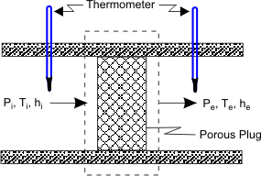

A gas at pressure and temperature flows continuously through a porous plug in a tube and emerges into a space which is maintained at a constant pressure. The device is thermally insulated and kept horizontal. Consider the dotted portion as control volume.



These results in

Therefore, whenever a fluid expands from a region of high pressure to a region of low pressure through a porous plug, partially opened valve or some obstruction, without exchanging any energy as heat and work with the surrounding (neglecting, the changes in PE and KE), the enthalpy of the fluid remains constant, and the fluid is said to have undergone a throttling process.

Free expansion (or unresisted expansion) process. A free expansion occurs when a fluid is allowed to expand suddenly into a vaccum chamber through an orifice of large dimensions. In this process, no heat is supplied or rejected and no external work is done. Hence the total heat of the fluid remains constant. This type of expansion may also be called as constant total heat expansion. It is thus obvious, that in a free expansion process,

Q1-2 = 0, W1-2 = 0 and dU = 0.

## van der Waals Equation of State:

The ideal gas law treats the molecules of a gas as point particles with perfectly elastic collisions. This works well for dilute gases in many experimental circumstances. But gas molecules are not point masses, and there are circumstances where the properties of the molecules have an experimentally measurable effect. A modification of the ideal gas law was proposed by Johannes D. van der Waals in 1873 to take into account molecular size and molecular interaction forces. It is usually referred to as the van der Waals equation of state.

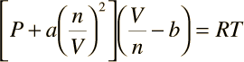

The constants a and b have positive values and are characteristic of the individual gas. The van der Waals equation of state approaches the ideal gas law PV=nRT as the values of these constants approach zero. The constant a provides a correction for the intermolecular forces. Constant b is a correction for finite molecular size and its value is the volume of one mole of the atoms or molecules.

Since the constant b is an indication of molecular volume, it could be used to estimate the radius of an atom or molecule, modeled as a sphere. Fishbane et al. give the value of b for nitrogen gas as 39.4 x 10-6 m3/mol.

# UNIT-IV

## Mixtures of perfect Gases:

A mixture, consisting of several pure substances, is referred to as a solution. Examples of pure substances are water, ethyl alcohol, nitrogen, ammonia, sodium chloride, and iron. Examples of mixtures are air, consisting of nitrogen, oxygen and a number of other gases, aqueous ammonia solutions, aqueous solutions of ethyl alcohol, various metal alloys. The pure substances making up a mixture are called components or constituents.

## Mixture of ideal gases

Basic assumption is that the gases in the mixture do not interact with each other.

Consider a mixture with components *l = 1,2,3.*.. with masses m1, m2, m3 ...m*i* and with number of moles.

The total mixture occupies a volume V, has a total pressure P and temperature T (which is also the temperature of each of the component species)

The total mass

 (4.1)

Total number of mole N

 (4.2)

Mass fraction of species *i*



Mole fraction of species *i*

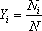

The mass and number of moles of species *i* are related by



is the number of moles of species i and is the molar mass of species *i*

Also to be noted

(4.3)

(4.4)

(4.5)

|  |  |
| --- | --- |
| and | (4.6) |

We can also define a molar mass of the mixture as

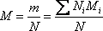(4.7)

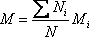or,

or,

## Dalton 's Law of partial pressure

Total pressure of an ideal gas mixture is equal to the sum of the partial pressures of the constituent components, That is

 (4.9)

P is the total pressure of the mixture P*i* is the partial pressure of species *i*

= pressure of the species if it existed alone in the given temperature T and volume V

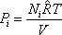 (4.10)

is the universal gas constant = 8.314 kJ/k mol K

## Amagat's Law:

Volume of an ideal gas mixture is equal to the sum of the partial volumes

 (4.11)

V = total volume of the mixture

V*i* = partial volume of the species *i*

= volume of the species if it existed alone in the given temperature T and pressure

For an ideal gas

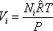Amagat's Law

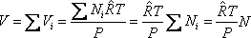

Or

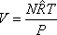

The volume fraction of species *I*

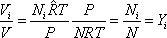

or,

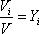

Volume fraction = Mole fraction

Mass based analysis is known as gravimetric analysis Mole based analysis is known as molar analysis

## Mole Fraction:

(4.12)

(4.13)

(34.16)

The composition of a gas mixture can be described by the mole fractions of the gases present. The mole fraction ( X ) of any component of a mixture is the ratio of the number of moles of that component to the total number of moles of all the species present in the mixture ( ntot ):

xA=moles of A/total moles

=na/ntot

=nA/(nA+nB+⋯)

The mole fraction is a dimensionless quantity between 0 and 1.

If xA=1.0 , then the sample is pure A , not a mixture. If xA=0 , then no A is present in the mixture.

The sum of the mole fractions of all the components present must equal 1.

To see how mole fractions can help us understand the properties of gas mixtures, let’s evaluate the ratio of the pressure of a gas A to the total pressure of a gas mixture that contains A . We can use the ideal gas law to describe the pressures of both gas A and the mixture: PA=nART/V and Ptot=ntRT/V . The ratio of the two is thus

PA/Ptot= nA/ntot=xA PA=XAPtot

## Mass Fraction:

the mass fraction of a substance within a mixture is the ratio of the mass of that substance to the total mass of the mixture.

Expressed as a formula, the mass fraction is According to the conservation of mass, we have:

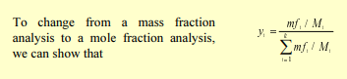

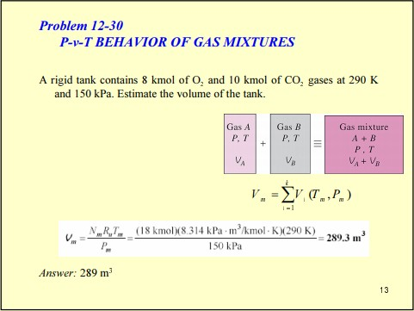

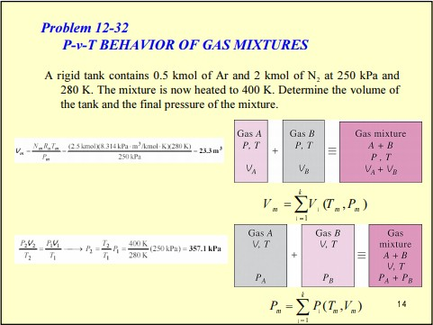

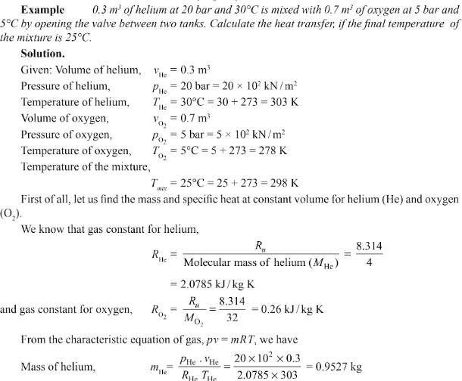

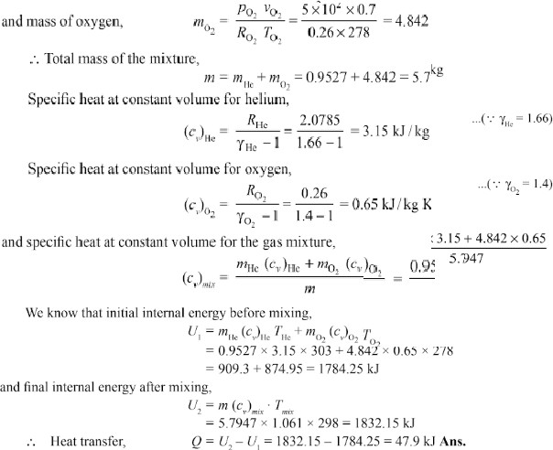

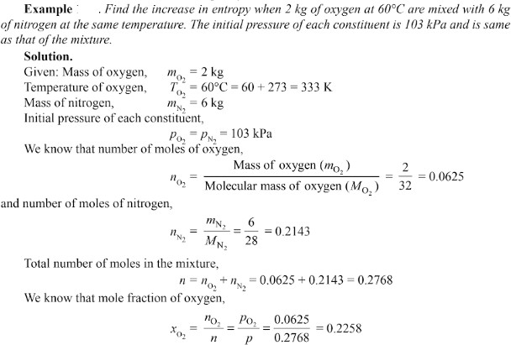

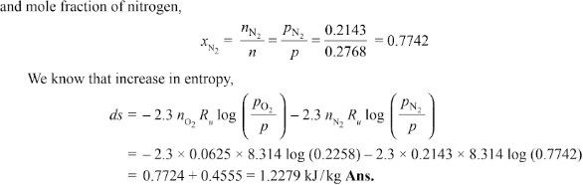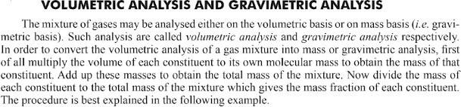

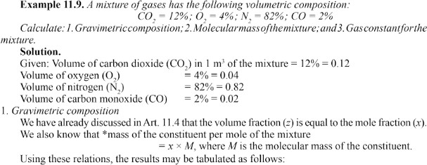

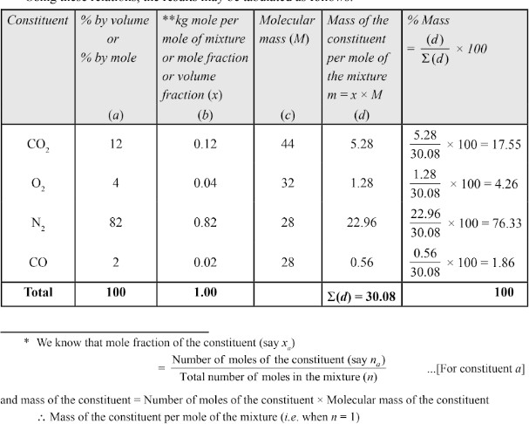

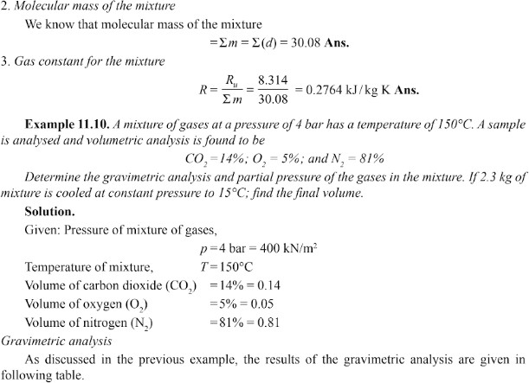

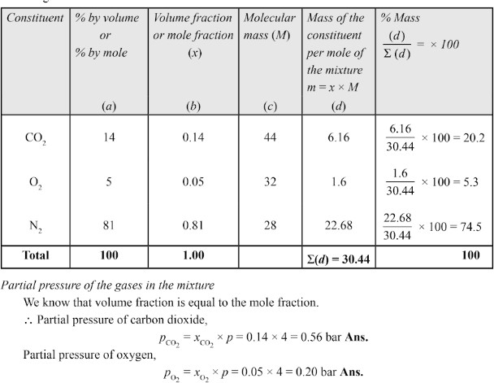

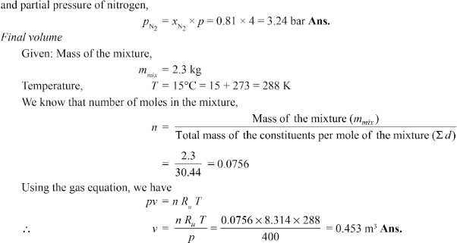

## Atmospheric Air:

Atmospheric air makes up the environment in almost every type of air conditioning system. Hence a thorough understanding of the properties of atmospheric air and the ability to analyze various processes involving air is fundamental to air conditioning design.

Psychrometry is the study of the properties of mixtures of air and water vapour.

Atmospheric air is a mixture of many gases plus water vapour and a number of pollutants The amount of water vapour and pollutants vary from place to place. The concentration of water vapour and pollutants decrease with altitude, and above an altitude of about 10 km, atmospheric air consists of only dry air. The pollutants have to be filtered out before processing the air. Hence, what we process is essentially a mixture of various gases that constitute air and water vapour. This mixture is known as moist air.

## Psychrometric Properties:

Dry bulb temperature (DBT) is the temperature of the moist air as measured by a standard thermometer or other temperature measuring instruments.

Saturated vapour pressure (psat) is the saturated partial pressure of water vapour at the dry bulb temperature. This is readily available in thermodynamic tables and charts.

ASHRAE suggests the following regression equation for saturated vapour pressure of water, which is valid for 0 to 100oC.

Relative humidity (Φ) is defined as the ratio of the mole fraction of water vapour in moist air to mole fraction of water vapour in saturated air at the same temperature and pressure. Using perfect gas equation we can show that:

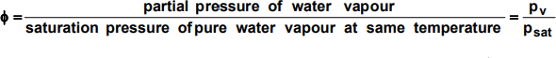

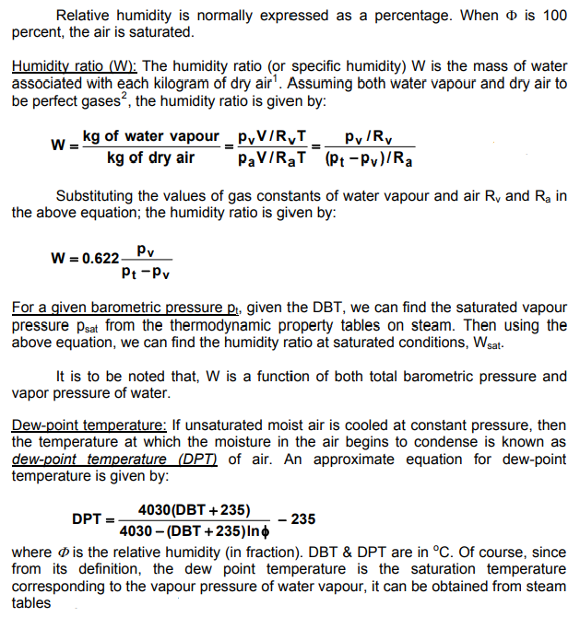

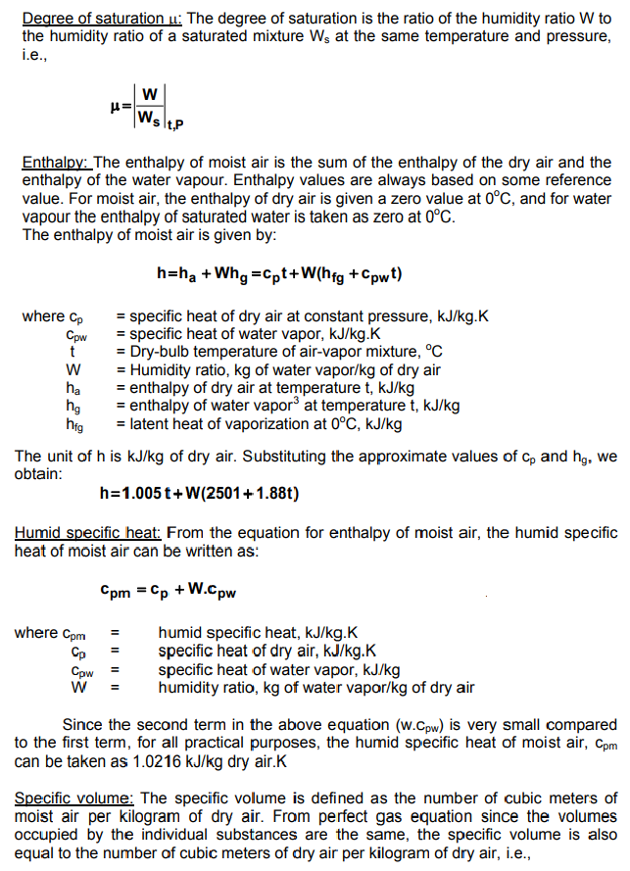

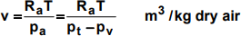

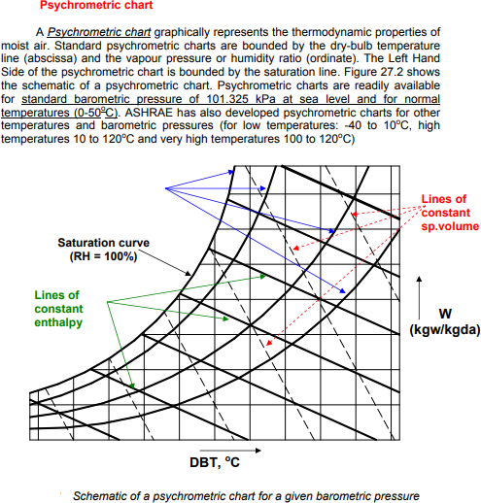

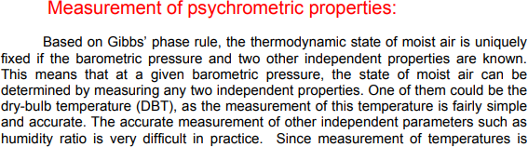

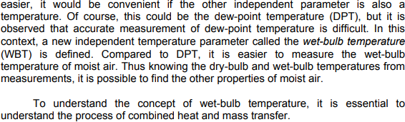

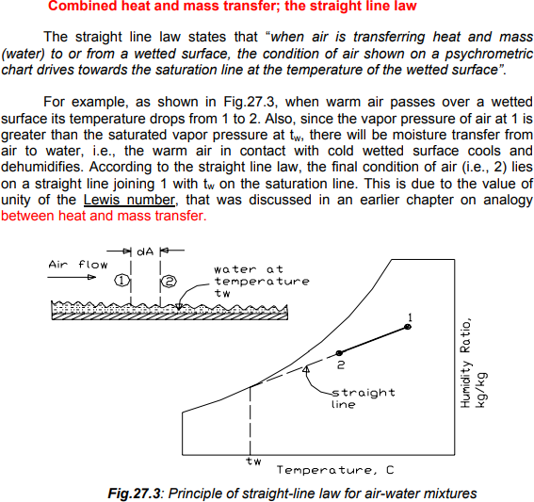

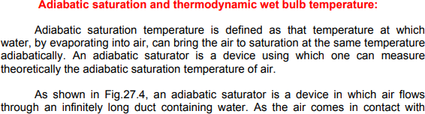

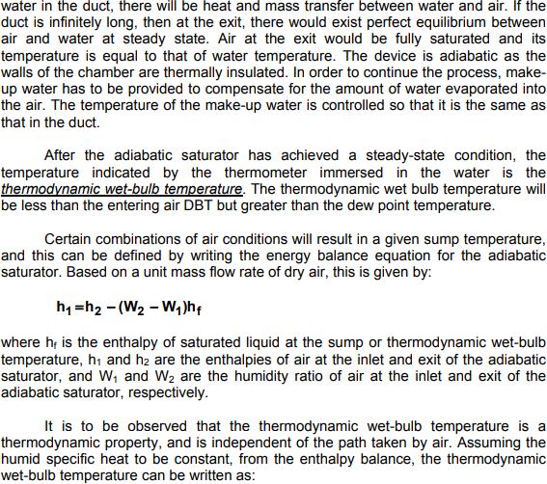

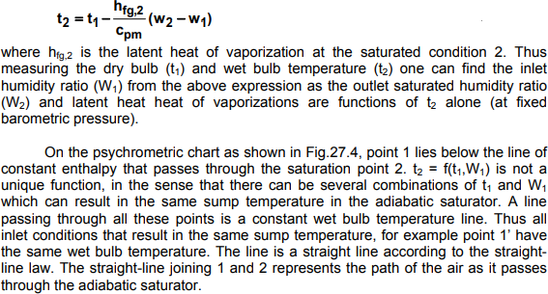

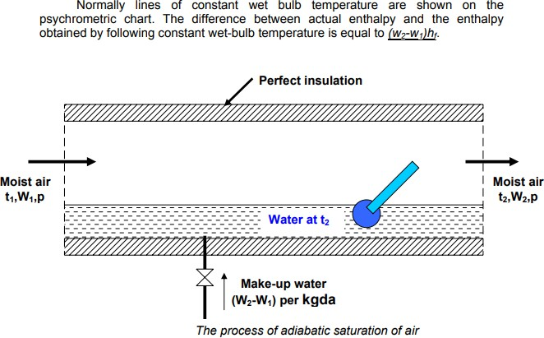

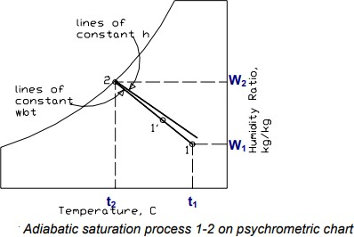

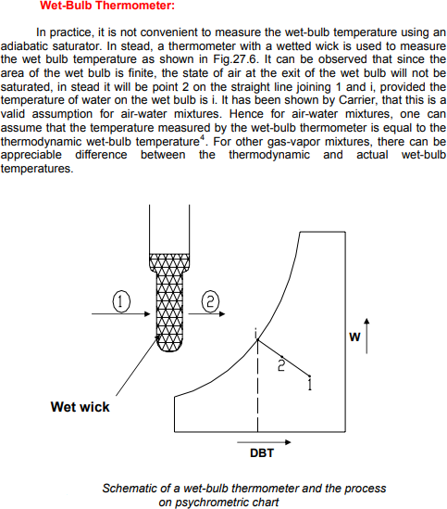

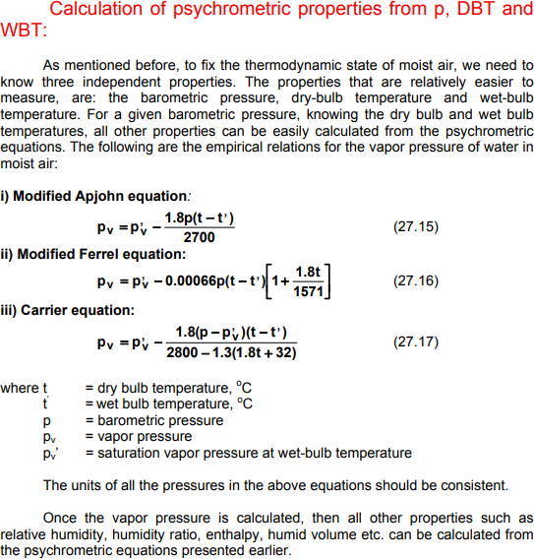

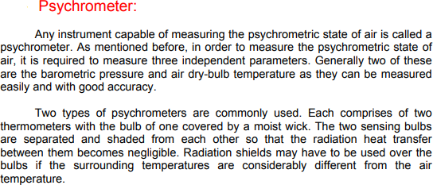

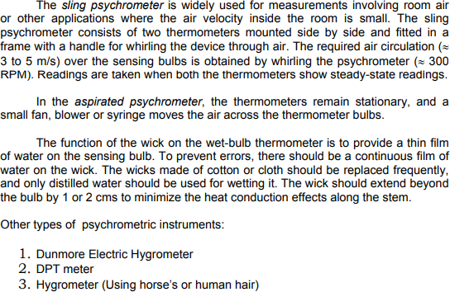

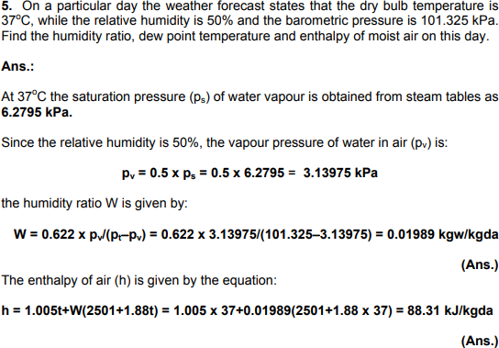

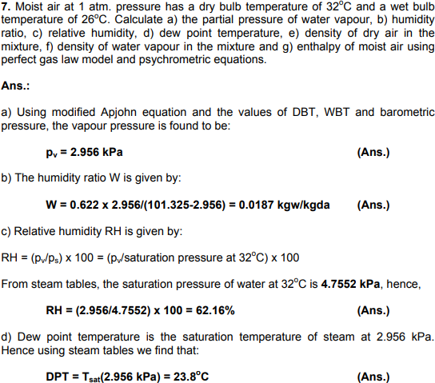

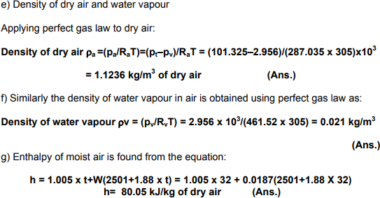

# UNIT-V

## Gas Power Cycles Introduction

For the purpose of thermodynamic analysis of the internal combustion engines, the following approximations are made:

* The engine is assumed to operate on a closed cycle with a fixed mass of air which does not undergo any chemical change.
* The combustion process is replaced by an equivalent energy addition process from an external source.
* The exhaust process is replaced by an equivalent energy rejection process to external surroundings by means of which the working fluid is restored to the initial state.
* The air is assumed to behave like an ideal gas with constant specific heat. These cycles are usually referred to as air standard cycle.

## Otto Cycle

The Air Standard Otto cycle is named after its inventor **Nikolaus A. Otto** . Figures 5.1 (a), (b) and (c) illustrate the working principles of an Otto cycle. The Otto cycle consists of the following processes.

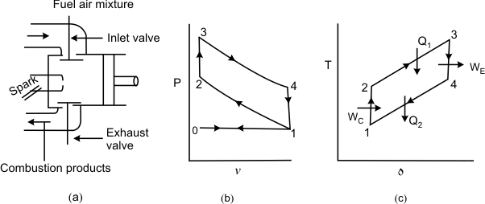

**Figure 5.1**

0-1: Constant pressure suction during which a mixture of fuel vapour and air is drawn into the cylinder as the piston executes an outward stroke.

1-2: The mixture is compressed isentropically due to the inward motion of the piston. Because of the **isentropic compression** , the temperature of the gas increases.

2-3: The hot fuel vapour-air mixture is ignited by means of an electric spark. Since the combustion is instantaneous, there is not enough time for the piston o move outward. This process is approximated as a **constant volume energy addition process** .

3-4: The hot combustion products undergo **isentropic expansion** and the piston executes an outward motion.

4-1: The exhaust port opens and the combustion products are exhausted into the atmosphere. The process is conveniently approximated as a **constant-volume energy rejection process**.

1-0: The remaining combustion products are exhausted by an inward motion of the piston at constant pressure.

Effectively there are four strokes in the cycle. These are suction, compression, expression, and exhaust strokes, respectively. From the P-V diagram it can be observed that the work done during the process 0-1 is exactly balanced by the work done during 1-0. Hence for the purpose of thermodynamic analysis we need to consider only the cycle 1-2-3-4, which is air- standard Otto Cycle.

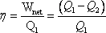 (5.1)

Where and denote the energy absorbed and energy rejected in the form of heat. Application of the first law of thermodynamics to process 2-3 and 4-1 gives:

 (5.2)

 (5.3)

Therefore,

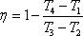 (5.4)

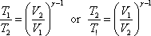1-2 and 3-4 are isentropic processes for which constant Therefore,

(5.5)

and

But

Hence

So,

or

and

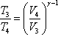 (5.6)



|  |  |
| --- | --- |
| and | (5.7) |

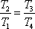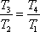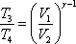 (5.8)

|  |  |
| --- | --- |
| or | (5.9) |

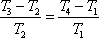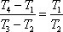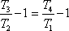 (5.10)

|  |  |
| --- | --- |
| or | (5.11) |

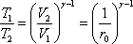 (5.12)

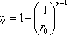(5.13)

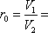Where

|  |  |
| --- | --- |
| **Compression ratio** | (5.14) |

Since , the efficiency of the Otto cycle increases with increasing compression ratio. However, in an actual engine, the compression ratio can not be increased indefinitely since

higher compression ratios give higher values of and this leads to **spontaneous** and **uncontrolled** combustion of the gasoline-air mixture in the cylinder. Such a condition is usually called knocking.

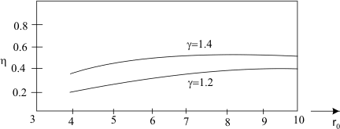

## Figure 5.2

Performance of an engine is evaluated in terms of the efficiency (see Figure 5.2). However, sometime it is convenient to describe the performance in terms of mean effective pressure, an imaginary pressure obtained by equating the cycle work to the work evaluated by the following the relation

(5.15)

The mean effective pressure is defined as the net work divided by the displacement volume. That is

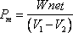

## DIESEL CYCLE

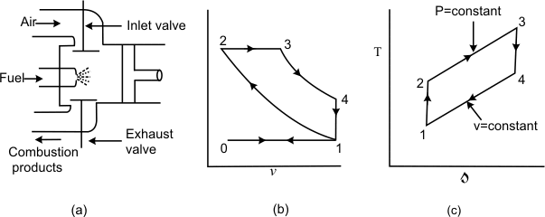

**Figure 5.3 (a), (b) and (c)**

The Diesel cycle was developed by Rudolf Diesel in Germany. Figures 5.3 (a), (b) and

1. explain the working principle of an Air Standard Diesel cycle. The following are the processes.

0-1: Constant pressure suction during which fresh air is drawn into the cylinder as the piston executes the outward motion.

1-2: The air is compressed isentropically. Usually the compression ratio in the **Diesel cycle is much higher them that of Otto cycle**. Because of the high compression ratio, the temperature of the gas at the end of isentropic compression is so high that when fuel is injected, it gets ignited immediately.

2-3: The fuel is injected into the hot compressed air at state 2 and the fuel undergoes a chemical reaction. The combustion of Diesel oil in air is not as spontaneous as the combustion of gasoline and the combustion is relatively slow. Hence the piston starts moving outward as combustion take place. The combustion processes is conveniently approximated as **a constant pressure energy addition process**.

3-4: The combustion products undergo isentropic expansion and the piston executes an outward motion.

4-1: The combustion products are exhausted at constant volume when the discharge port opens. This is replaced by a **constant-volume energy rejection process**.

1-0: The remaining combustion products are exhausted at constant pressure by the inward motion of the piston.

In the analysis of a Diesel cycle, two important parameters are: compression

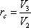ratio and the cut-off ratio . The cut-off ratio is defined as the ratio of the volume at the end of constant-pressure energy addition process to the volume at the beginning of the energy addition process.

|  |
| --- |
| (5.16) |
| (5.17) |
| Energy added |

|  |  |
| --- | --- |
| Energy rejected | (5.18) |

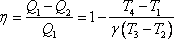 (5.19)

or

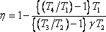 (5.20)

## 1-2 is Isentropic:



**4-1 is Constant volume:**

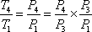

But

Hence

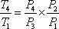

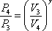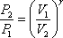Since **1−2** and **3−4** are isentropic processes 

and

Hence

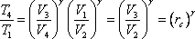

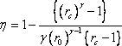

Also to be noted

(5.21)

(5.22)

(5.23)

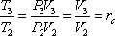The compression ratios normally in the Diesel engines vary between 14 and 17.

## AIR STANDARD DUAL CYCLE

Figures 5.4 (a) and (b) shows the working principles of a Dual cycle. In the dual cycle, the energy addition is accomplished in two stages: Part of the energy is added at constant volume and part of the energy is added at constant pressure. The remaining processes are similar to those of the Otto cycle and the Diesel cycle. The efficiency of the cycle can be estimated in the following way

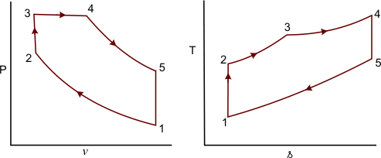

## Figure 5.4.1 (a) and (b)

Energy added



Energy rejected



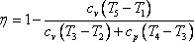

or

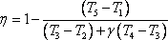

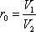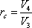The efficiency of the cycle can be expressed in terms of the following ratios

(5.24)

(5.25)

(5.25)

(5.26)

|  |  |
| --- | --- |
| Compression ratio, | (5.27) |

|  |  |
| --- | --- |
| Cut-off ratio, | (5.28) |

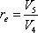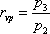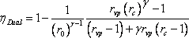

|  |  |
| --- | --- |
| Expansion ratio, | (5.28) |

|  |  |
| --- | --- |
| Constant volume pressure ratio, | (5.29) |

|  |
| --- |
| (5.30) |
| If |
| If |

## https://nptel.ac.in/courses/112104113/lecture30/30_2_clip_image002_0000.gifComparison of Otto, Diesel & Dual Cycles

For same compression ratio and heat rejection (Figures 5.5 (a) and (b))

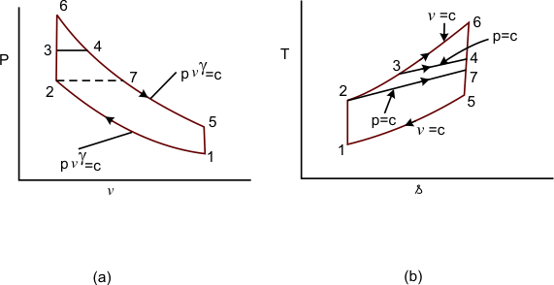

## Figure 5.5 (a) and (b)

1-6-4-5: Otto cycle

1-7-4-5: Diesel cycle

1-2-3-45 Dual cycle

For the same Q2 , the higher the Q1 , the higher is the cycle efficiency



For the same maximum pressure and temperature (Figures 5.6 (a) and (b))

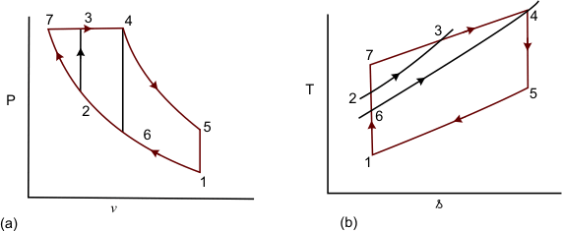

## Figure 5.6 (a) and (b)

1-6-4-5: Otto cycle

1-7-4-5: Diesel cycle

1-2-3-45 Dual cycle Q1 is represented by:

|  |  |  |  |
| --- | --- | --- | --- |
| Area | under 6-4 | for | Otto cycle |
| area | under 7-4 | for | Diesel cycle |

and

area under 2-3-4 for Dual cycle and Q2 is same for all the cycles



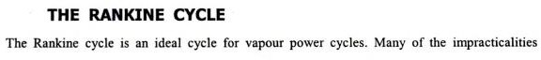

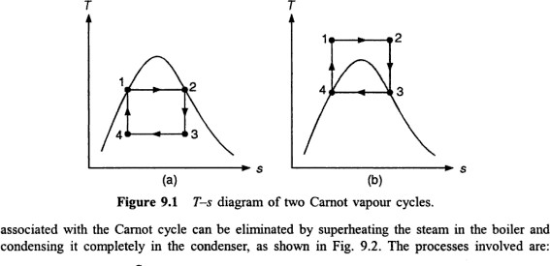

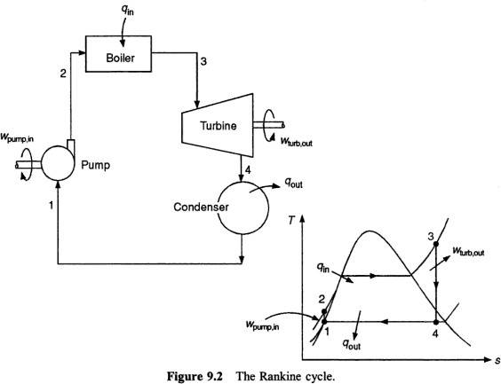

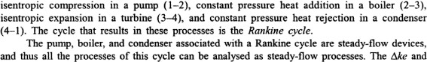

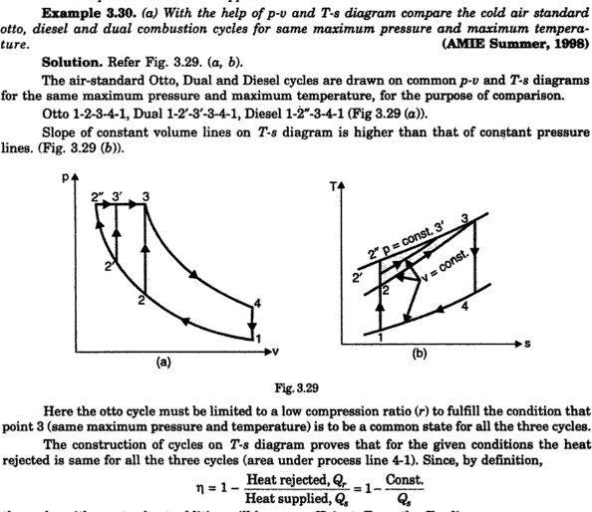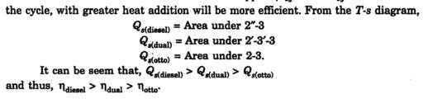

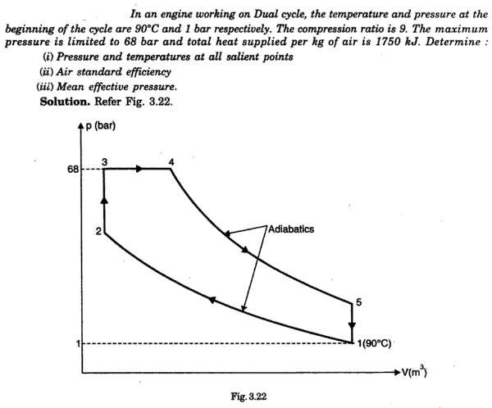

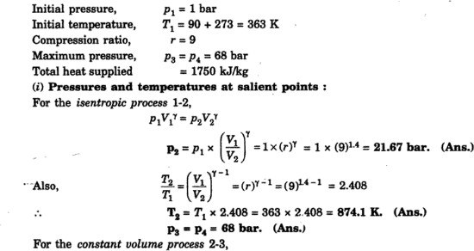

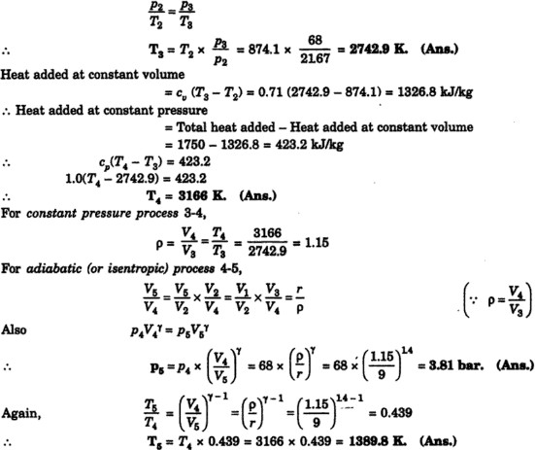

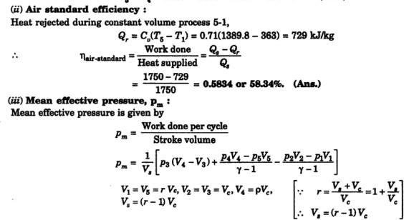

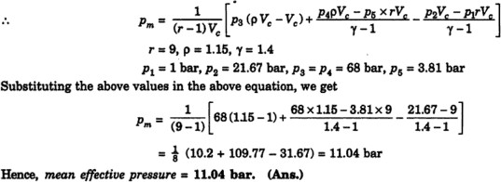

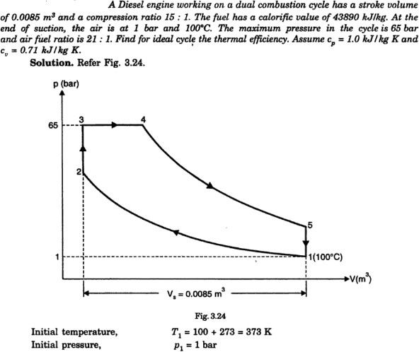

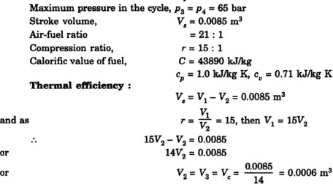

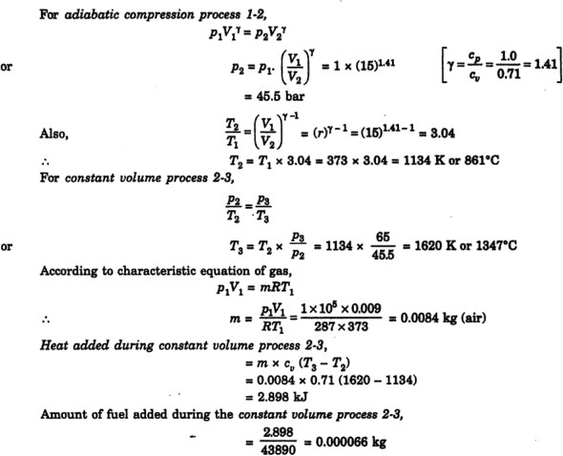

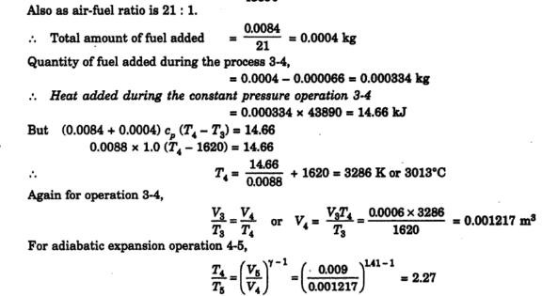

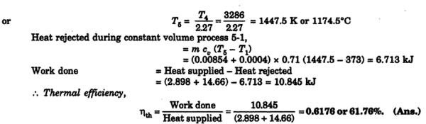

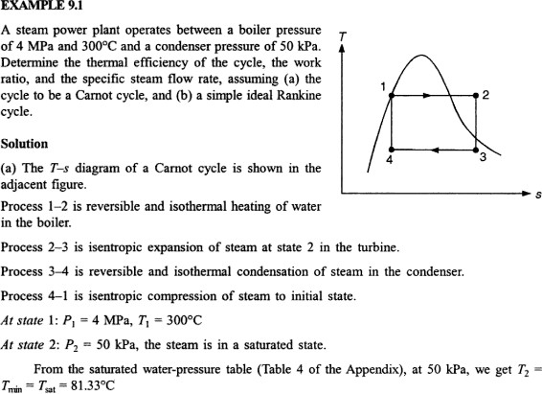

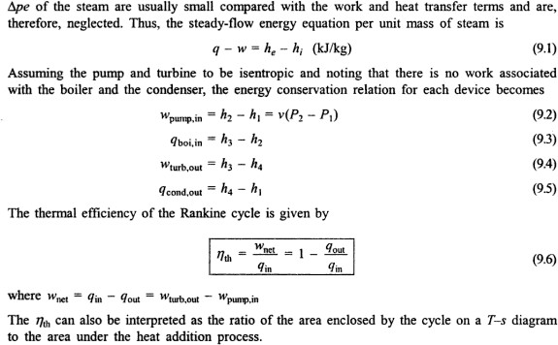

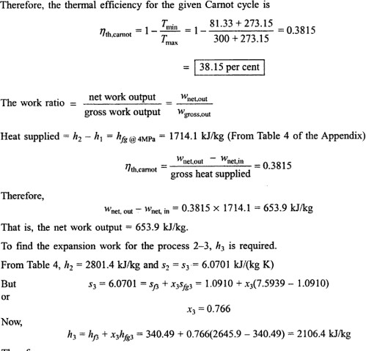

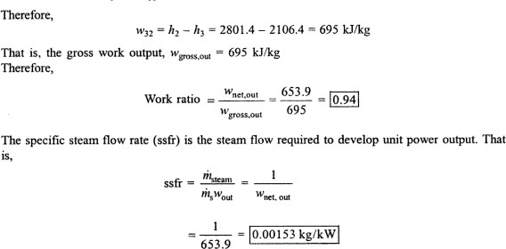

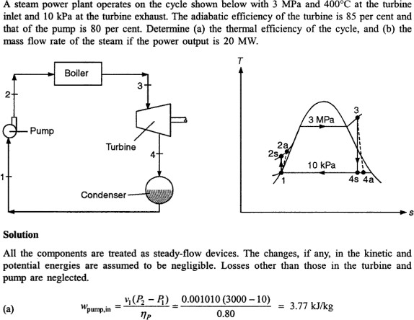

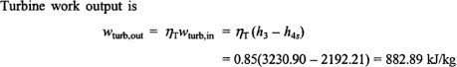

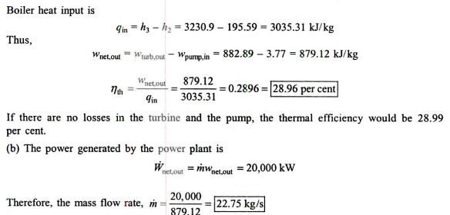

# QUESTION BANK

## UNIT-I

1. Explain briefly the following terms with diagram (wherever necessary)
   1. Thermodynamic System, Surroundings & Boundary
   2. Control Volume & Control Surface
   3. Intensive & Extensive Property
   4. Path Function & Point Function
   5. Thermodynamic Equilibrium
2. Describe the working principle of constant volume gas thermometer with a neat sketch.
3. State and explain quasi- static process.
4. List out the causes of irreversibility and explain.
5. State and explain first law of thermodynamics with its corollaries.
6. Prove that ‘Energy’ is a point function of a system undergoing change of state.
7. A stationary mass of gas is compressed without friction from an initial state of 0.35 m 3 and 0.11MPa to a final state of 0.25 m 3 at constant pressure. There is a transfer of 48.67 kJ of heat from the gas during the process. How much does the internal energy of the gas change?
8. 0.2m3 of air at 3 bar and 1200C is contained in a system. A reversible adiabatic expansion takes place till the pressure falls to 1.5 bar. The gas is then heated at constant pressure till enthalpy increases by 75 kJ. Calculate the work done and the index of expansion, if the above processes are replaced by a single reversible polytropic process giving the same work between the same initial and final states.

## UNIT-II

1. Write notes on the following a) Limitations of first law of thermodynamics b)Thermal energy reservoir c) Heat engine d) Heat pump e) COP
2. State and explain second law of thermodynamics with its corollaries.
3. Explain Carnot cycle with p-V and T-s diagrams and derive the expression for efficiency.
4. Describe briefly about Maxwell’s equations.
5. What is reversed Carnot heat engine? What are the limitations of Carnot cycle?
6. At the inlet to a certain nozzle the enthalpy of fluid passing is 2800 kJ/kg, and the velocity is 50 m/s. At the discharge end the enthalpy is 2600 kJ/kg. The nozzle is horizontal and there is negligible heat loss from it.
   1. Find the velocity at exit of the nozzle.
   2. If the inlet area is 900 cm2 and the specific volume at inlet is 0.187 m3/kg, find the mass flow rate.
   3. If the specific volume at the nozzle exit is 0.498 m3/kg, find the exit area of nozzle.
7. A **steam turbine** operates under steady flow conditions receiving steam at the following state:
   1. pressure 15 bar, internal energy 2700 kJ/kg, specific volume 0.17 m3/kg

and velocity 100 m/s. the exhaust of steam from the turbine is at 0.1 bar with internal energy 2175 kJ/kg, specific volume 0.15 m3/kg and velocity 300 m/s. The intake is 3 meters above the exhaust. The turbine develops 35 kW and heat loss over the surface of turbine is 20 kJ/kg. Determine the steam flow rate through the turbine.

1. A reversible engine receives heat from two thermal reservoirs maintained at constant temperature of 750 K and 500 K. The engine develops 100 kW and rejects 3600 kJ/min of heat to a heat sink at 250 K. Determine thermal efficiency of the engine and heat supplied by each thermal reservoir.

## UNIT-III

1. Explain the phase change of a pure substance on p-V-T surface.
2. Describe briefly about mollier chart.
3. Describe the working of combined separating and throttling calorimeter.
4. Explain briefly about the vanderwaals equation of state.
5. 2 kg. of gas at a temperature of 200 C undergoes a constant pressure process until the temperature is 1000 C. Find the heat transferred, ratio of specific heats, specific gas constant, work done, and change in entropy during the process. Take CV = 0.515 kJ/kg k, CP = 0.6448 kJ/kgk.
6. A container of 2 m3 capacity contains 10 kg of CO2 at 27°C. Estimate the pressure exerted by CO2 by using,a) Perfect gas equations and also using b) vanderwaals equation
7. Atmospheric air at 1.0132 bar has a DBT of 30°C and WBT of 24°C. Compute,
   1. The partial pressure of water vapour
   2. Specific humidity
   3. The dew point temperature
   4. Relative humidity
   5. Degree of saturation
   6. Density of air in the mixture
   7. Density of the vapour in the mixture
8. A vessel of 0.04 m2 Contains a mixture of saturated water and saturated steam at a temperature of 250°C. The Mass liquid present is 9kg . Find pressure, the mass, the specific volume, the enthalpy and entropy and the internal energy.

## UNIT-IV

1. Write notes on the following terms a) Mole Fraction b) Mass fraction c) Gravimetric and d) volumetric Analysis.
2. Write notes on the following terms a) Dry bulb Temperature b)Wet Bulb Temperature, c) Dew point Temperature d)Thermodynamic Wet Bulb Temperature

e) Specific Humidity f)Relative Humidity

1. Explain the various terms involved psychrometric chart.
2. 2 kg. of gas at a temperature of 20 0 C undergoes a constant pressure process until the temperature is 100 0 C. Find the heat transferred, ratio of specific heats, specific

gas constant, work done, and change in entropy during the process. Take Cv = 0.515 kJ/kgk Cp = 0.6448 kJ/kg k.

1. a) Write the differences between gravimetric and volumetric analysis.

b) 1.8 kg of oxygen at 480 C is mixed with 6.2 kg of nitrogen at the same temperature. Both oxygen and nitrogen are at the pressure of 102 k Pa before and after mixing. Find the increase in entropy.

1. A mixture of ideal air and water vapour at a DBT of 22°C and a total pressure of 730 mm Hg abs has a temperature of adiabatic saturation of 15°C. Calculate, (i) The specific humidity in gms per kg of dry air. (ii) The partial pressure of water vapour. (iii) The relative humidity (iv) Enthalpy of the mixture per kg of dry air.
2. An air-water vapour mixture enters an adiabatic saturator at 30°C and leaves at 20°C, which is the adiabatic saturation temperature. The pressure remains constant at 100 kPa. Determine the relative humidity and the humidity ratio of the inlet mixture.
3. State and explain Daltons’ law of partial pressures and Amgot’s law of additive volumes.

## UNIT-V

1. With p-V and T-s diagrams derive the efficiency of otto cycle.
2. With p-V and T-s diagrams derive the efficiency of Diesel cycle.
3. With p-V and T-s diagrams derive the efficiency of dual combustion cycle.
4. Differentiate between Otto cycle, diesel cycle and dual combustion cycle.
5. With p-V and T-s diagrams derive the efficiency of Rankine cycle.
6. An engine working on Otto cycle has a volume of 0.45 m3, pressure 1 bar and temperature 30°C at the beginning of compression stroke. At the end of compression stroke, the pressure is 11 bar. 210 kJ of heat is added at constant volume. Determine:
   1. Pressures, temperatures and volumes at salient points in the cycle.
   2. Percentage clearance.
   3. Efficiency.
   4. Mean effective pressure.
7. In a Diesel cycle, air a 0.1 MPa and 300 K is compressed adiabatically until the pressure rises to 5 MPa. If 700 kJ/kg of energy in the form of heat is supplied at constant pressure, determine the compression ratio, cutoff ratio, thermal efficiency and mean effective pressure.
8. An air-standard Diesel cycle has a compression ratio of 20, and the heat transferred to the working fluid per cycle is 1800 kJ/kg. At the beginning of the compression process, the pressure is 0.1 MPa and the temperature is 15°C. Consider ideal gas and constant specific heat model. Determine the pressure and temperature at each point in the cycle, The thermal efficiency, The mean effective pressure.

# PROJECTS

1. Fabrication of Solar air conditioning Machine
2. A Project on Water cooler cum Water heater by using refrigeration System
3. Improving the performance of an engine block for various cooling fluids.
4. A Project on Fabrication of double reflection solar Cooker
5. Experimental Investigation of Heat Recovery from R744 based Refrigeration System
6. Power Generation from Railway Track
7. Air powered cars
8. Air Powered Bike

**Video links**

1. <https://www.youtube.com/watch?v=qTYGloPSGec>
2. <https://www.youtube.com/watch?v=vJ_rsimoXV4>
3. <https://www.youtube.com/watch?v=JQLkiErH9x4&feature=youtu.be>
4. <https://www.youtube.com/watch?v=cdccGqpcNRw>
5. <https://www.youtube.com/watch?v=b5xR9rm6Zuc>
6. <https://www.youtube.com/watch?v=0VRD_ihjEBY>
7. <https://www.youtube.com/watch?v=uRpxhlX4Ga0>
8. <https://www.youtube.com/watch?v=UC3GtQjUpII>